Date May 3, 2020

Airline Market Analysis to

Improve NPS score

**Instructor:**

Steve Wallace

**Members:**

Renjie Zhu

Chaoying Lyu

CONTENTS

1. DATA PREPARATION 3

1.1 Mitigate Missing Data 3

1.2 Summarize variables 3

1.2.1 Age 3

1.2.2 Price Sensitivity 4

1.2.3 Flights Per Year 4

1.2.4 Loyalty 4

1.2.5 Total Frequent Flyer Accounts 5

1.2.6 Departure Delay in Minutes 5

1.2.7 Arrival Delay in Minutes 6

1.2.8 Flight time in minutes 6

1.2.9 Flight Distance 6

1.2.10 Likelihood to recommend 7

2. Exploratory Analysis 7

2.1 Segment 7

2.1.1 Detractors 7

2.1.2 Passives 8

2.1.3 Promoters: 9

2.1.4 Different variables in segments 10

2.1.5 Conclusion of segmentation 11

2.2 Sentiment Analysis 12

2.2.1 Cheapseats Airlines Comments 13

2.2.2 Other Partners Comments 15

2.3 Predictive Modeling 17

2.3.1 Random Forest 17

2.3.2 Naive Bayes 19

2.3.3 Support Vector Machine(SVM) 20

2.3.4 K-nearest Neighbors(k-NN) 20

2.3.5 Neural Network 21

2.3.6 Result comparison 22

3. Business Recommendations Development Phase 23

3.1 Business Analysis 24

3.1.1 FlyFast Airways Inc. 24

3.1.2 Other two Airways Inc. 26

3.1.3 Conclusion 29

3.2 Marketing Plan 29

3.2.1 Segment Persona’s 29

3.2.2 Market Plan for the segmentation 30

4. reference 33

# DATA PREPARATION

## Mitigate Missing Data

Missing Variables Summary

* Departure.Delay.in.Minutes(99,19.860%)
* Flight time in minutes(112, 2.2467%)
* Arrival Delay in Minutes(112, 2.2467%)
* FreeText (4884, 97.9739%)

Here are several options in impute widget: average, as a distinct value, model-based imputer, random values, remove instances, specific value.

For freetext attribute, since each review is unique and we could not create passengers’ reviews by ourselves, we chose to remove those missing values and only analyze those existing reviews.

For departure delay and arrival delay in minutes, we replaced the missing values with the mean of the columns because the mean was an accurate enough representation of the delay.

For flight time in minutes, we also used average value to substitute those missing values. It is obvious that the flight time in minutes is correlated with the origin city and destination city, but since we have 4985 rows in total and only have 112 missing values, simply replacing the missing values with average value would not influence the model performance very much.

## Summarize variables

## Age

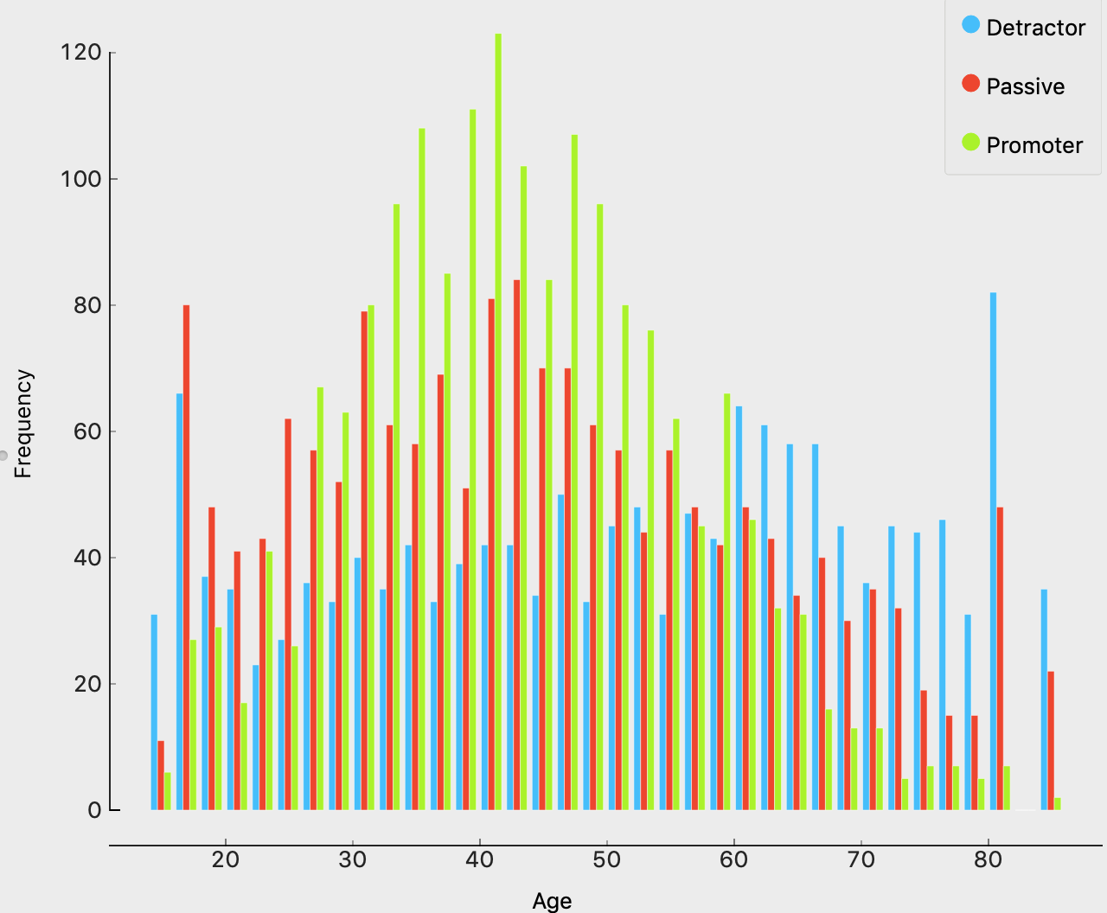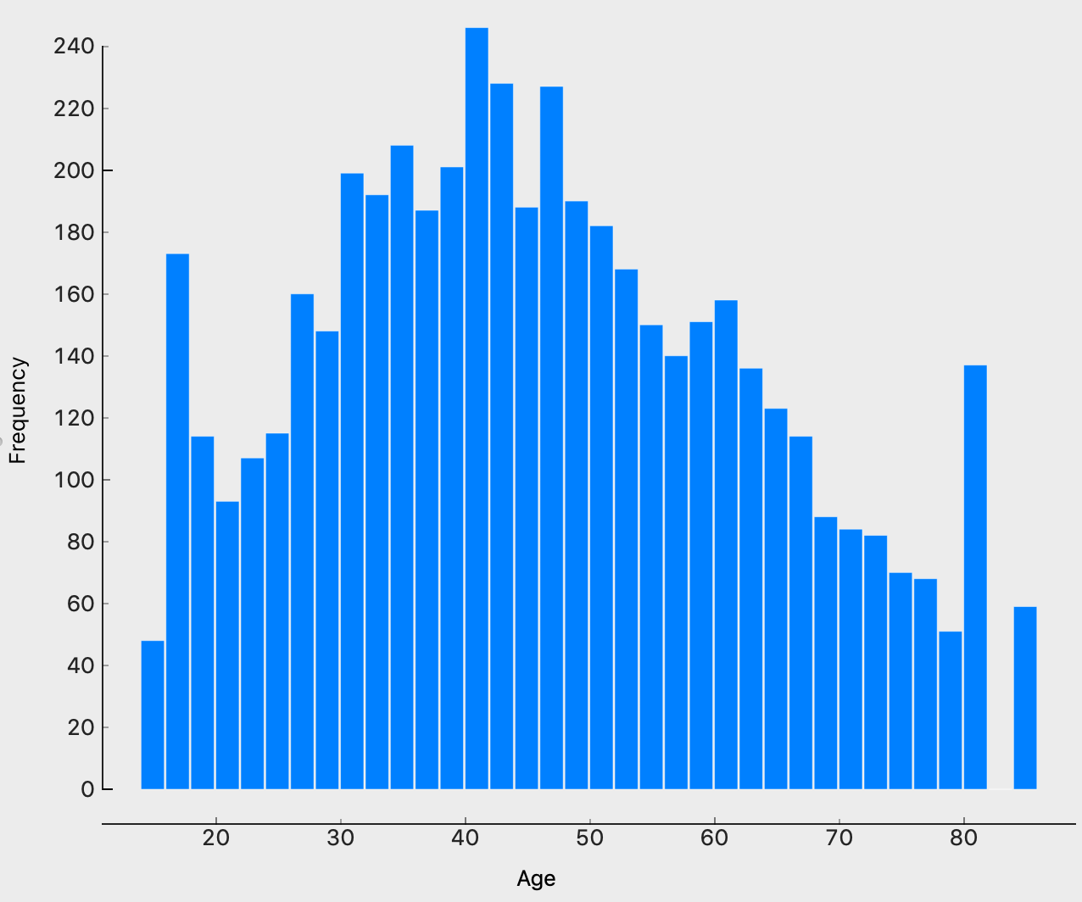

The shape of histogram issymmetric, we could see that the age distribution basically conforms to the normal distribution.

## Price Sensitivity

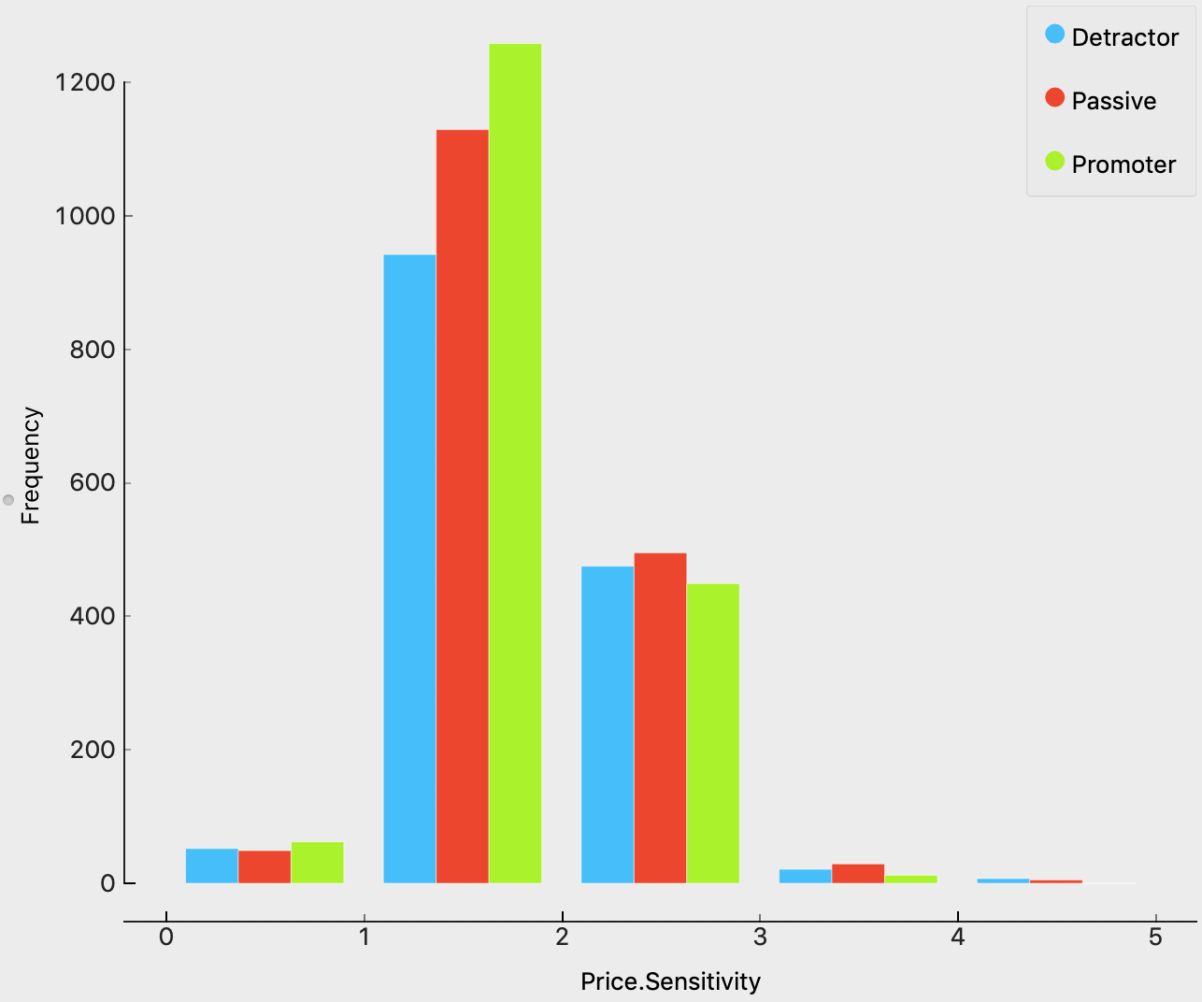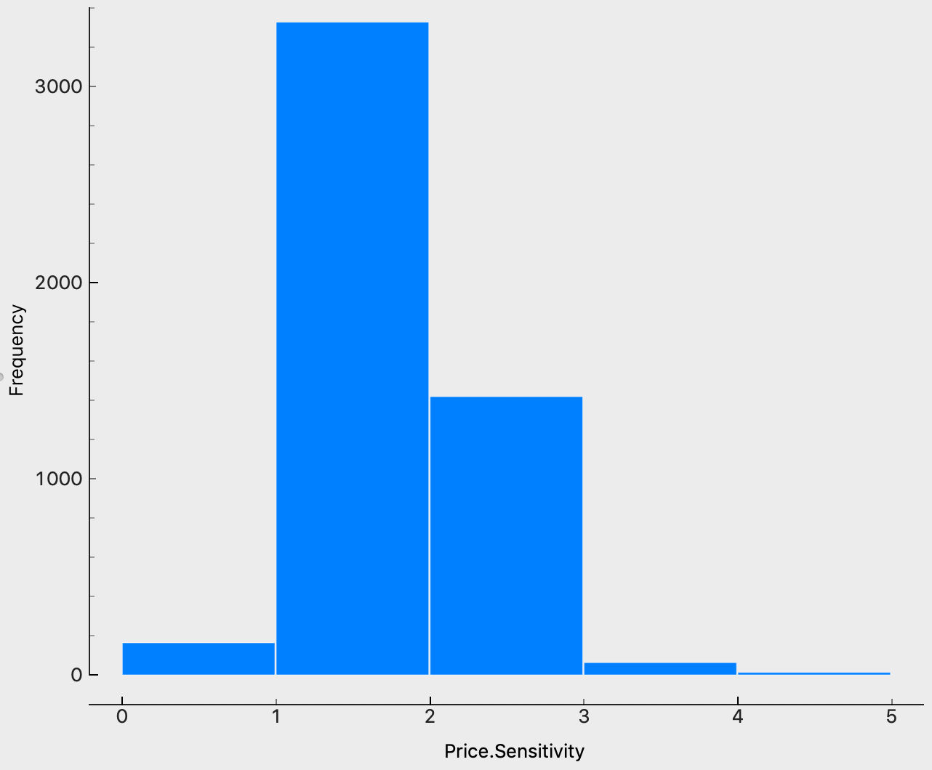

The shape of histogram ispositively skewed (long right tail), few people gave a 4 or 5 sensitivity score.

## Flights Per Year

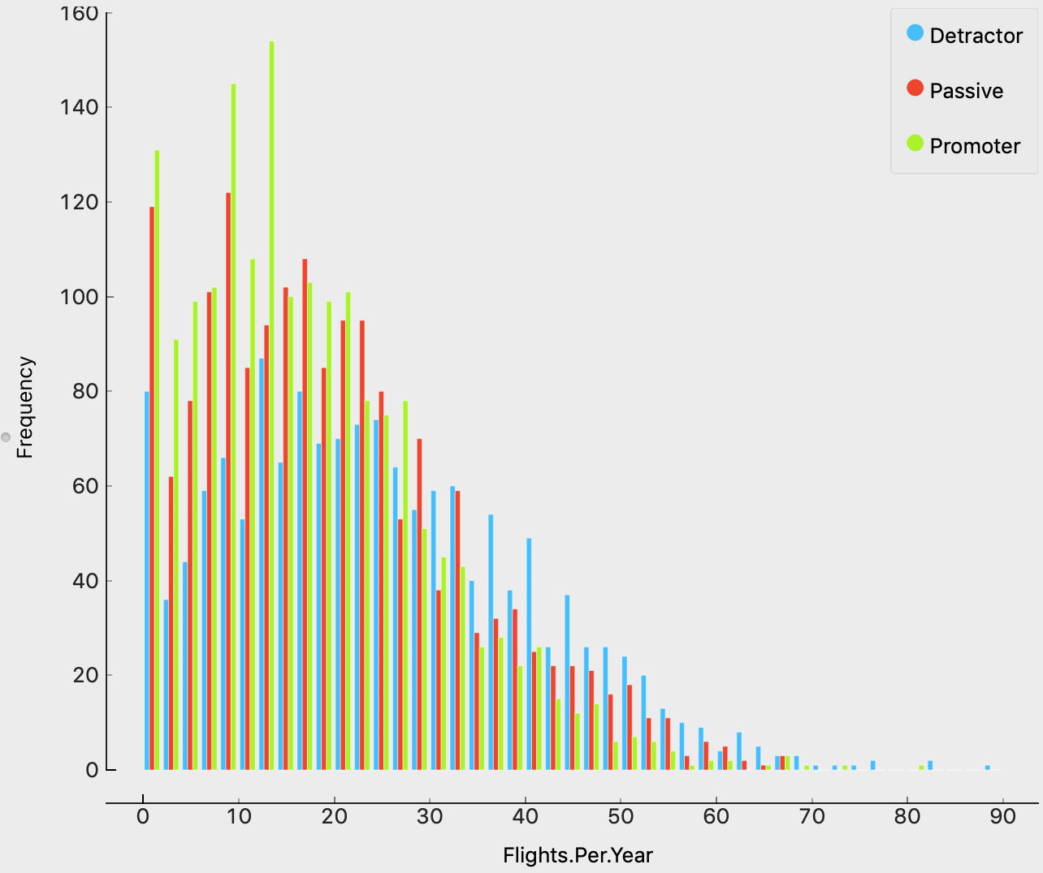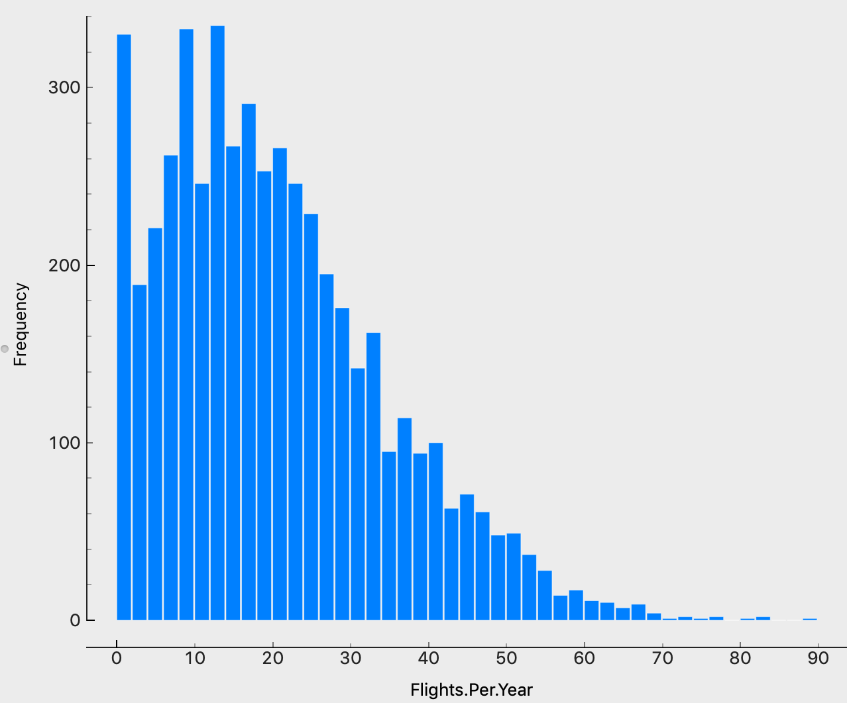

The shape of histogram ispositively skewed (long right tail), most people had less than 40 flights per year.

## Loyalty

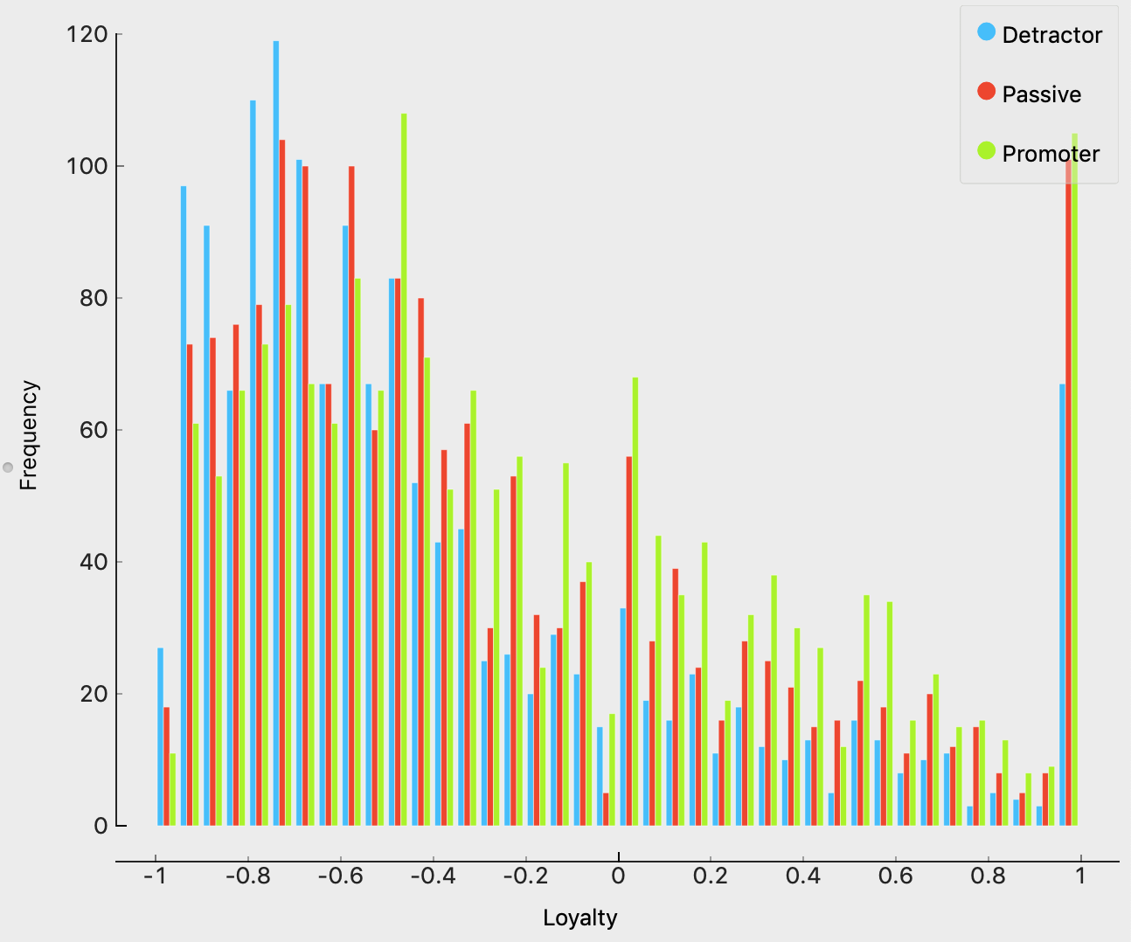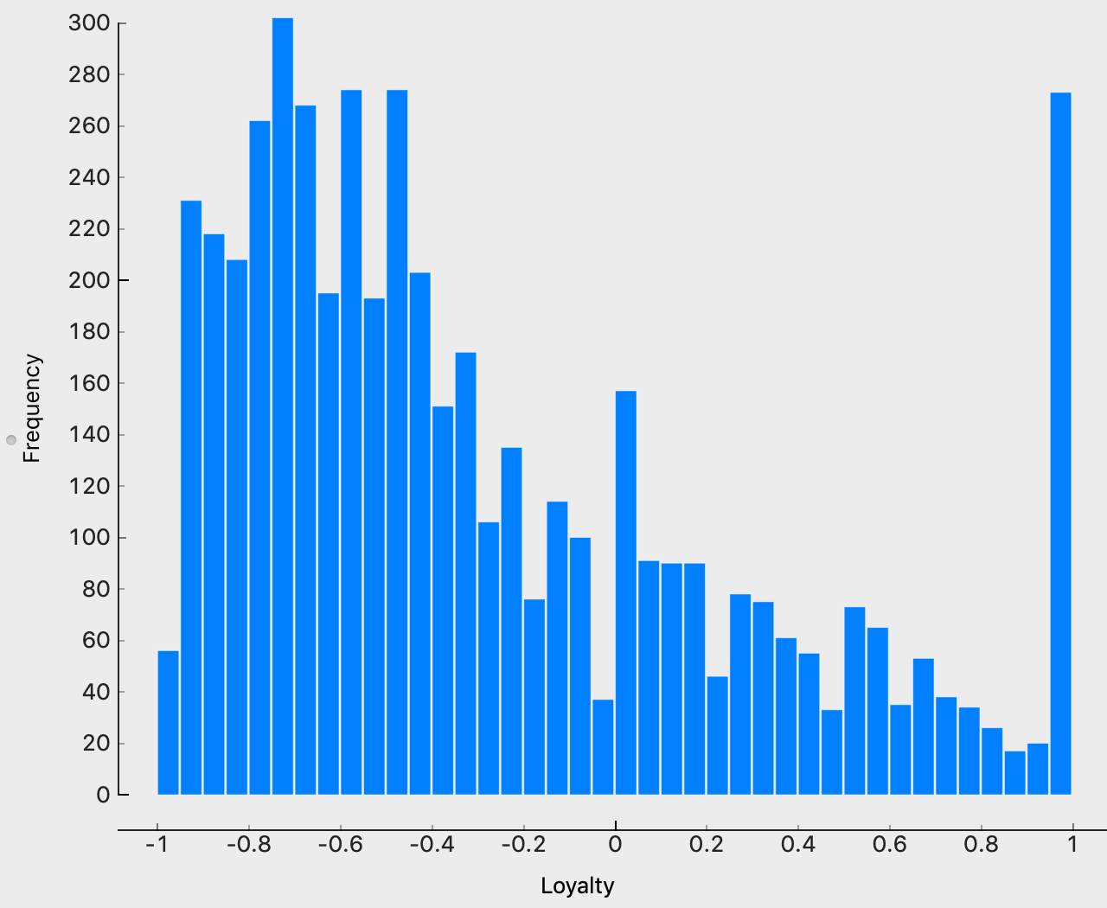

The shape of histogram ispositively skewed (long right tail), most passengers had a negative loyalty score, but there was one exception, many people’s loyalty scores were equal to 1.

## Total Frequent Flyer Accounts

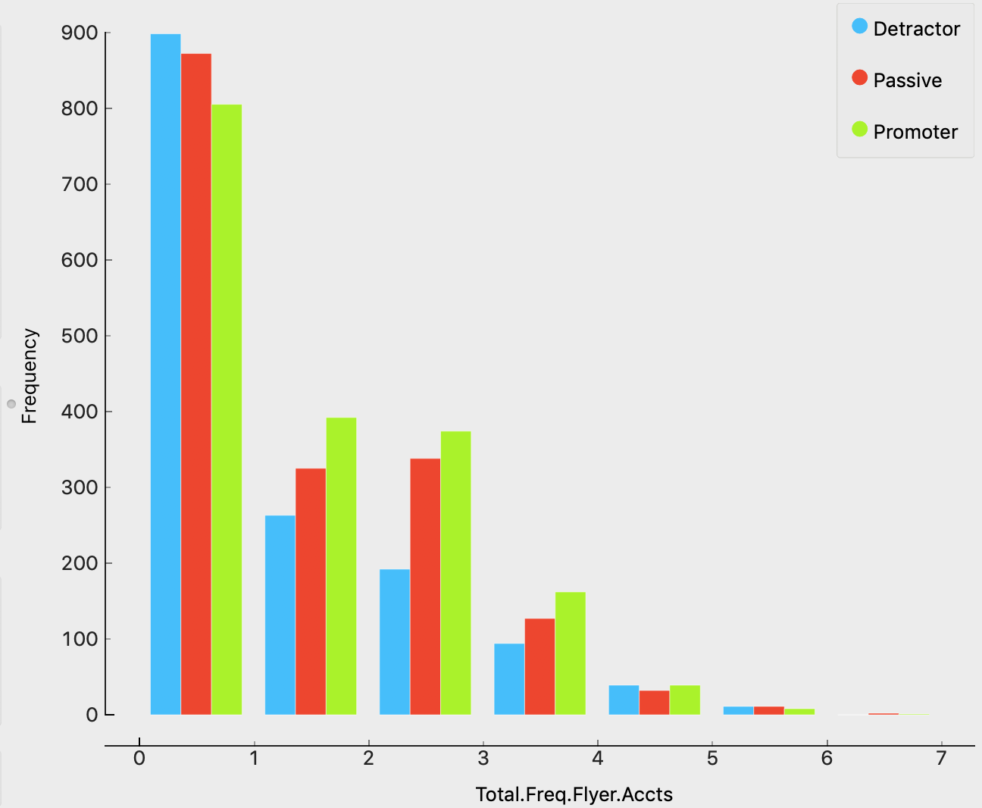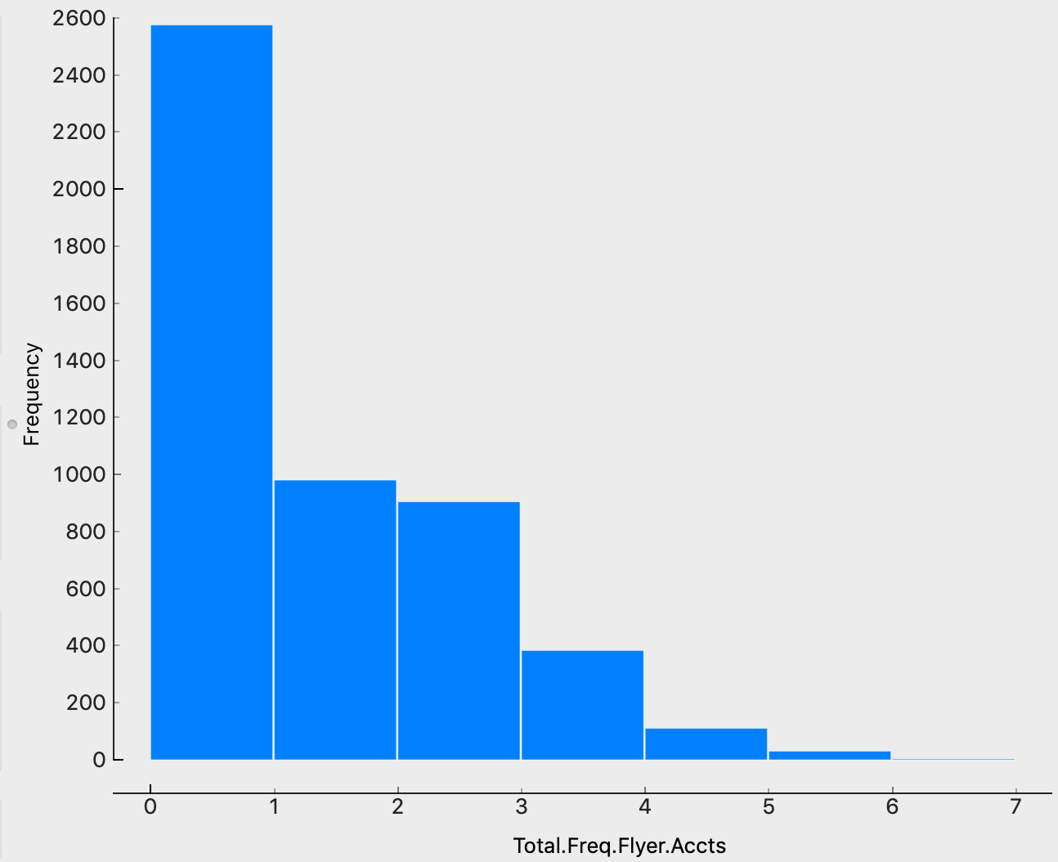

The shape of histogram ispositively skewed (long right tail), most scores were lower than 3.

## Departure Delay in Minutes

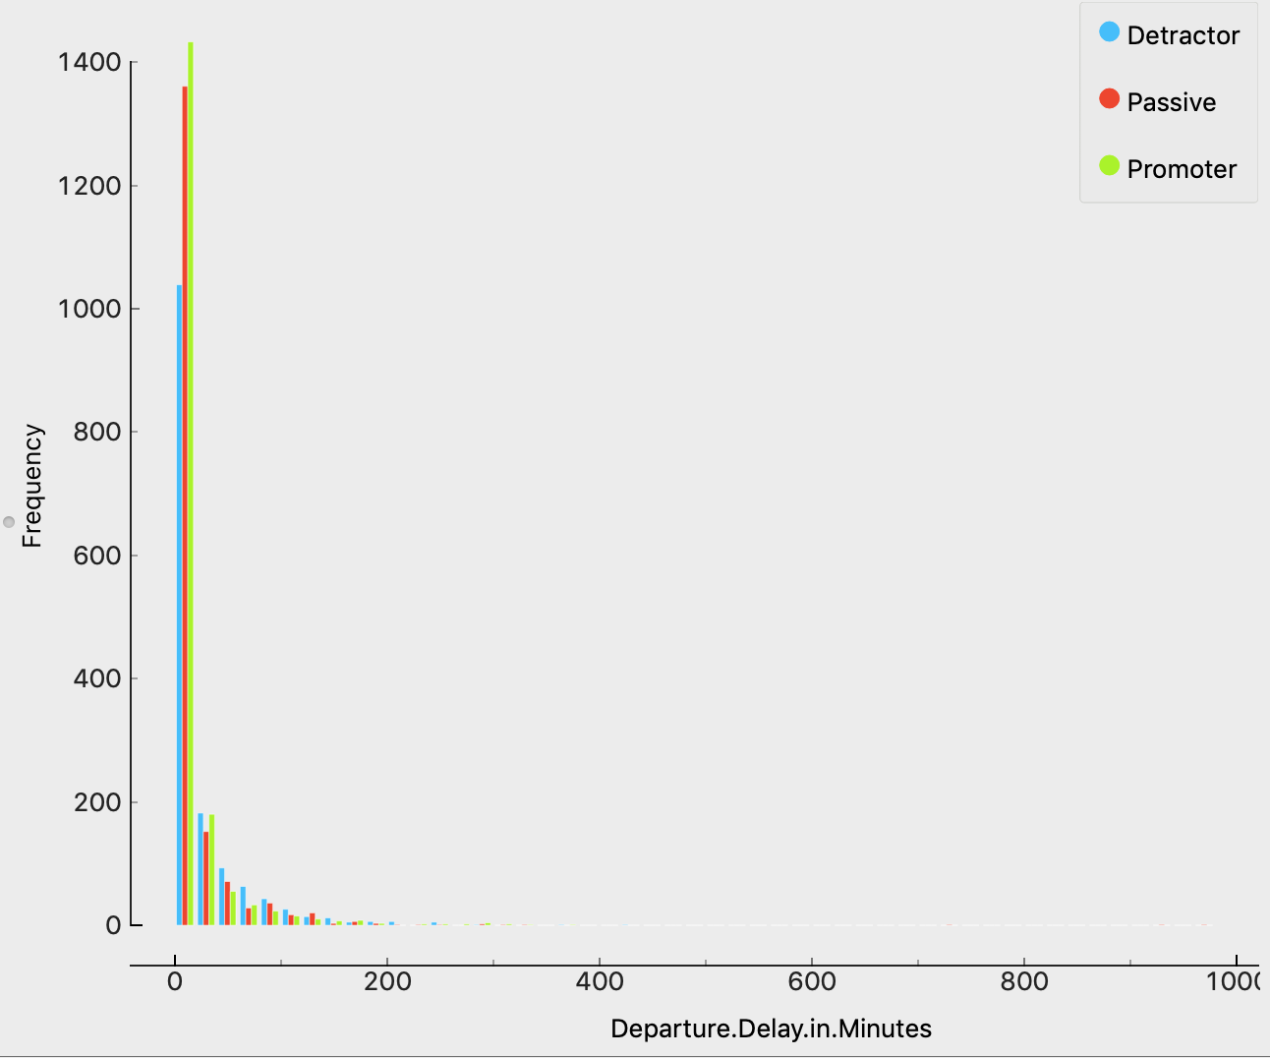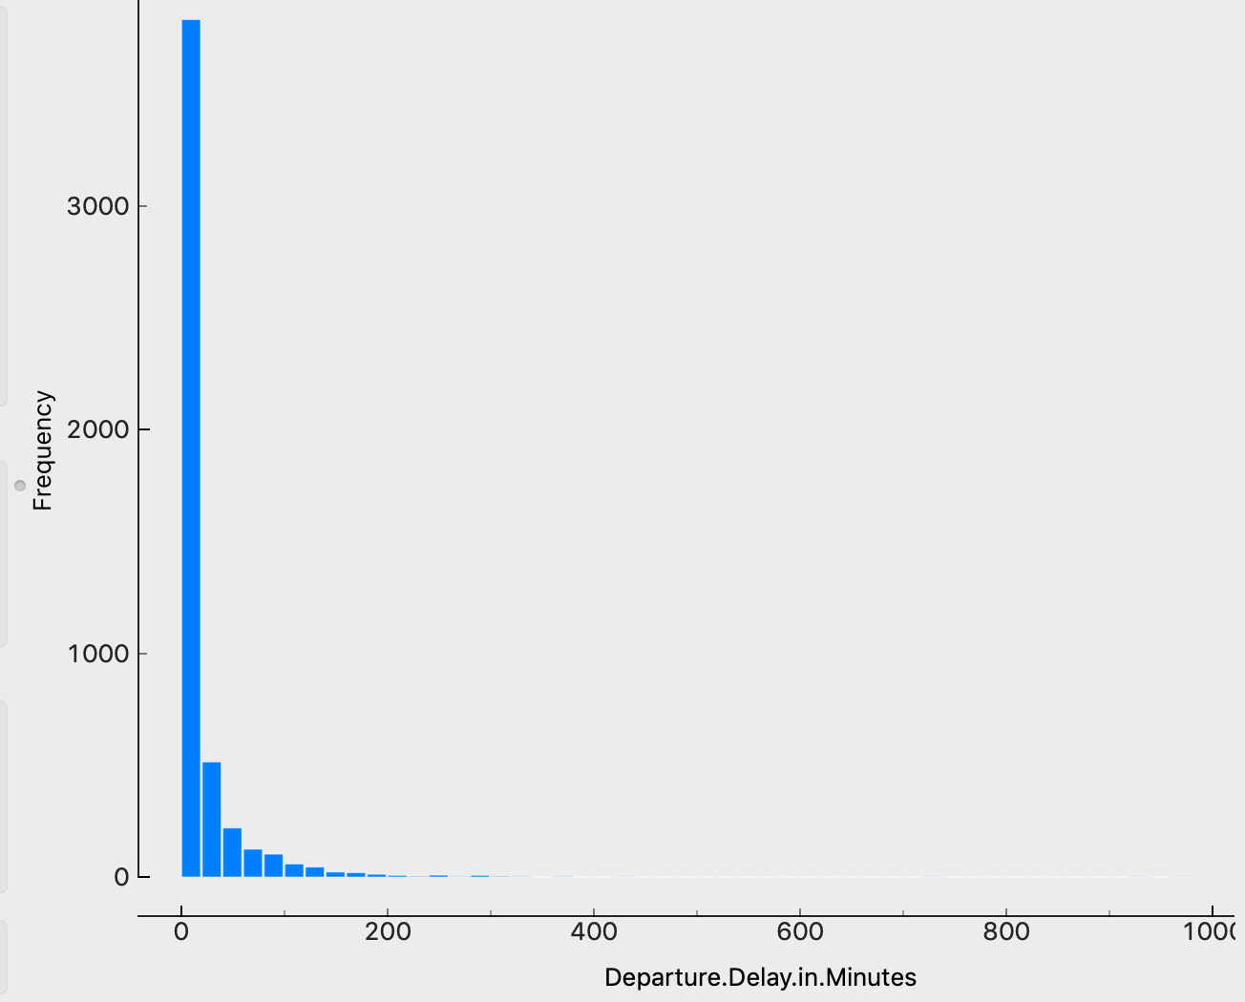

The shape of histogram ispositively skewed (long right tail), very few people had long departure delay time.

## Arrival Delay in Minutes

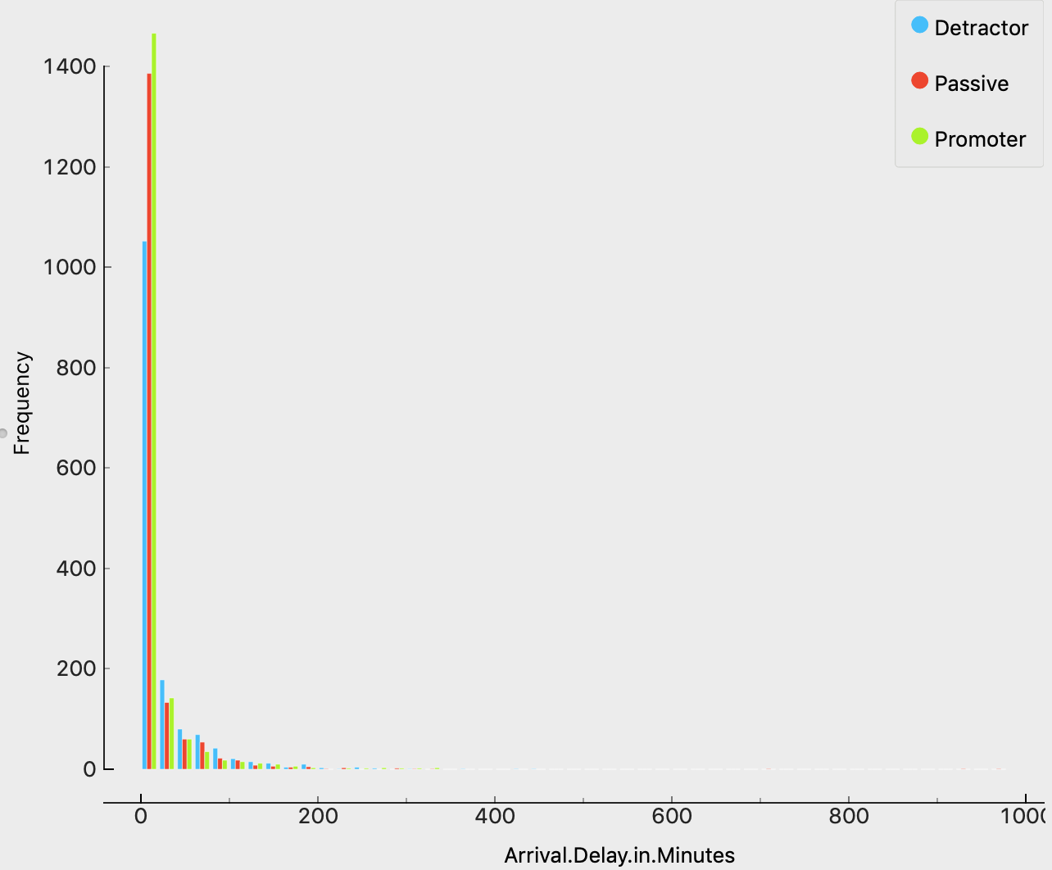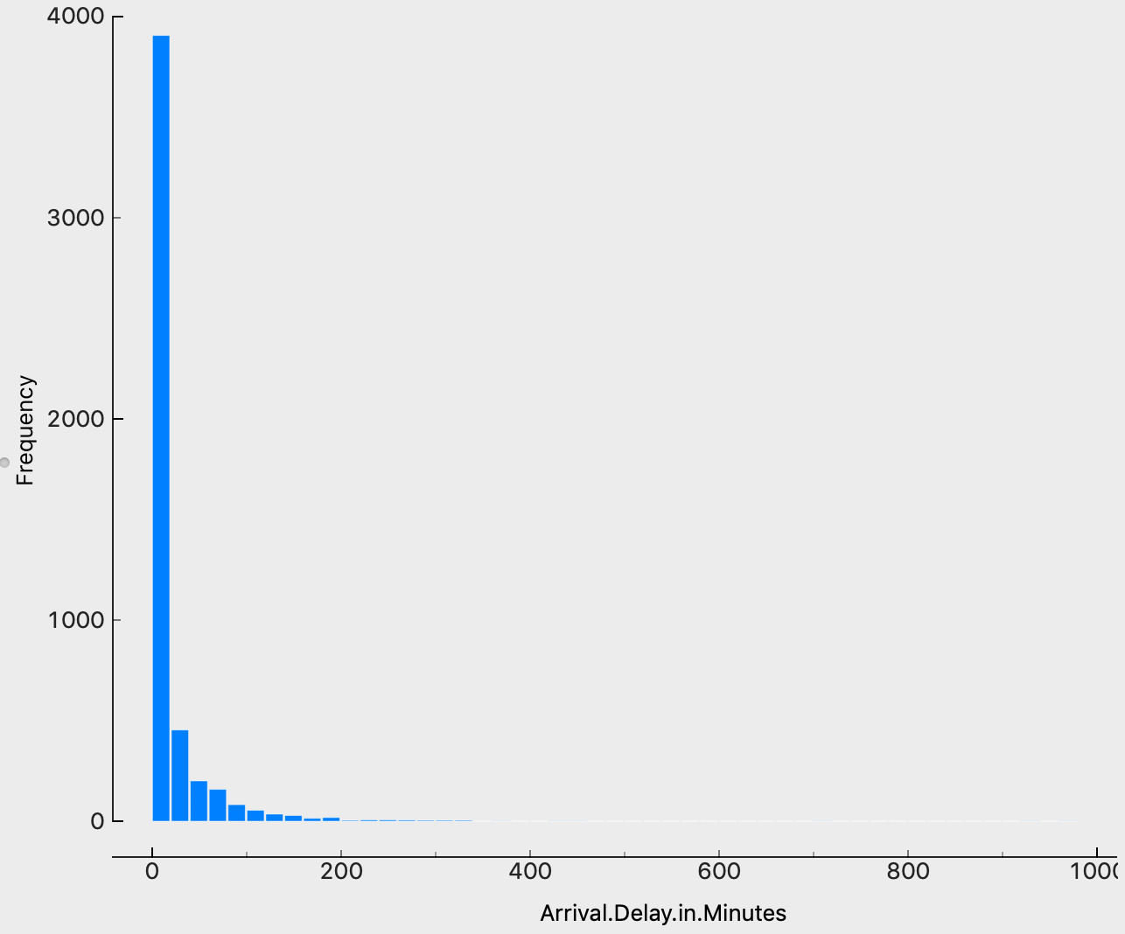

The shape of histogram ispositively skewed (long right tail), very few people had long arrival delay time.

## Flight time in minutes

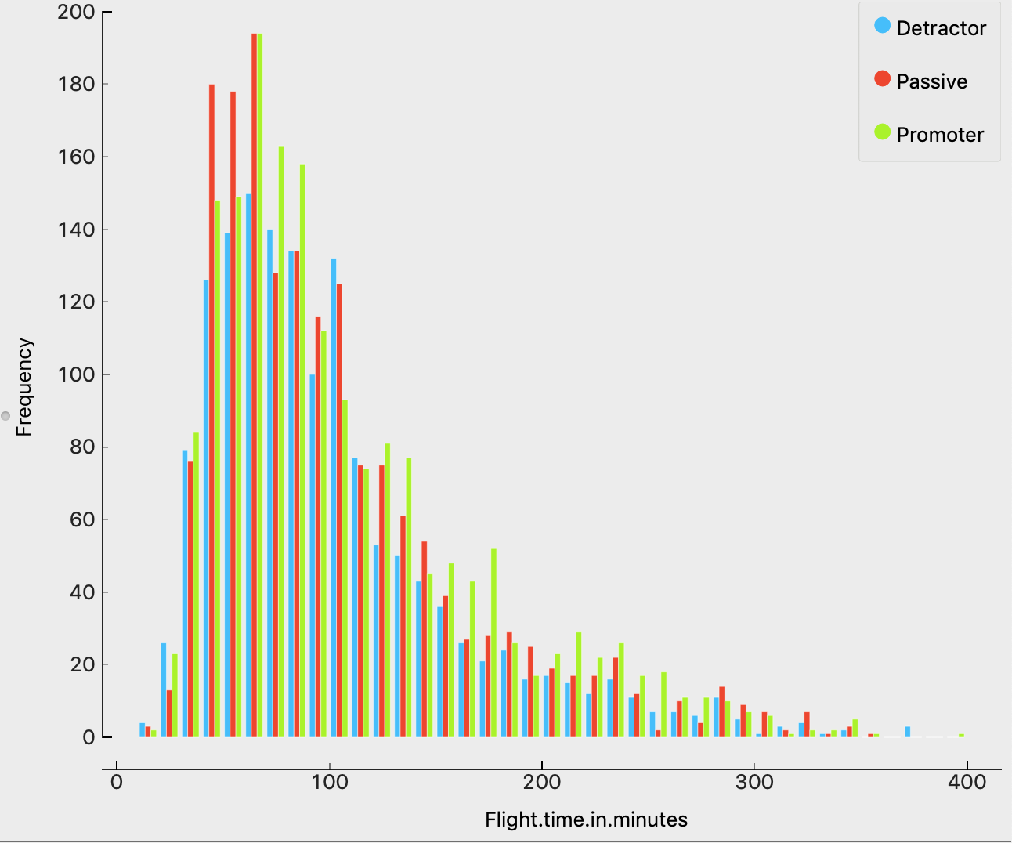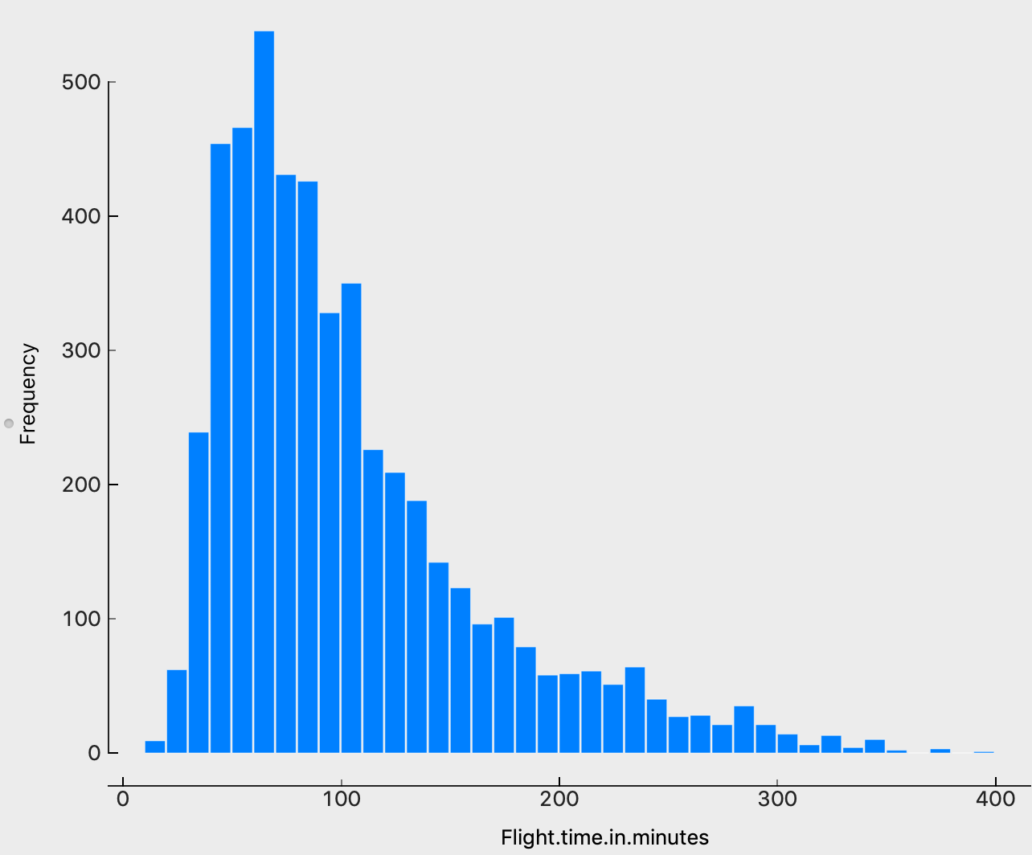

The shape of histogram ispositively skewed (long right tail), most passengers took short-haul flights.

## Flight Distance

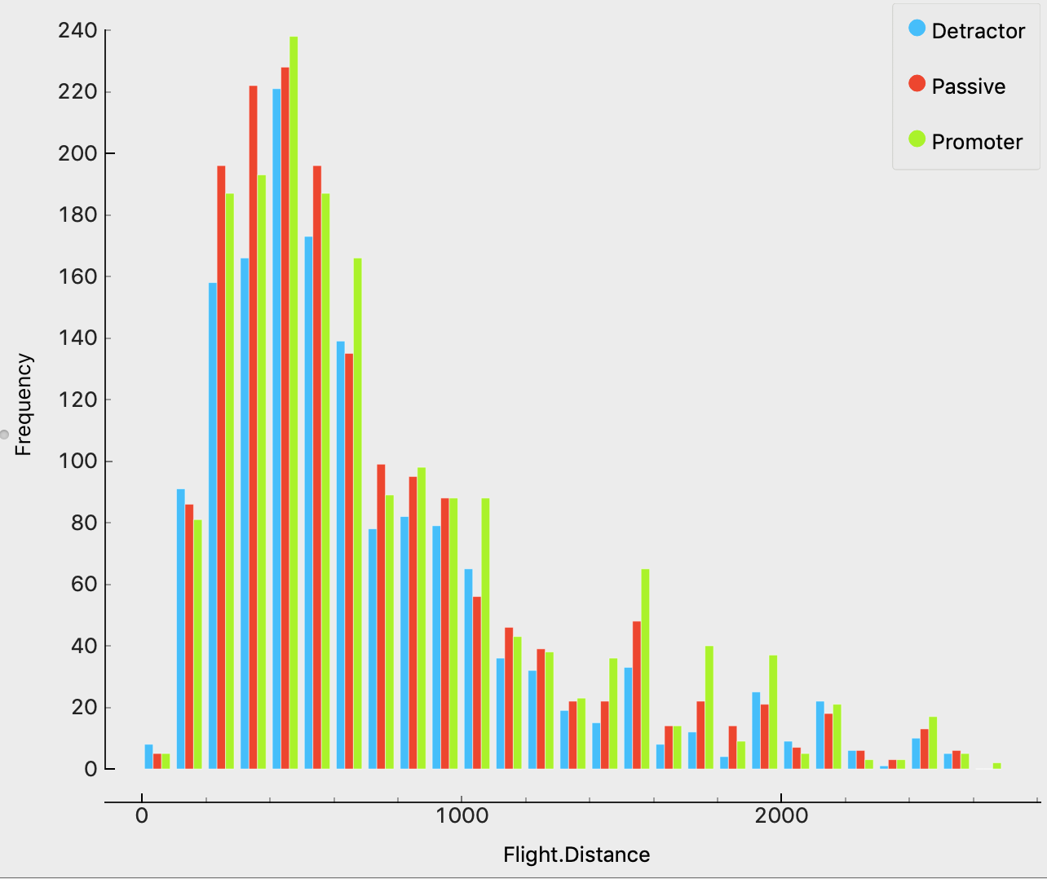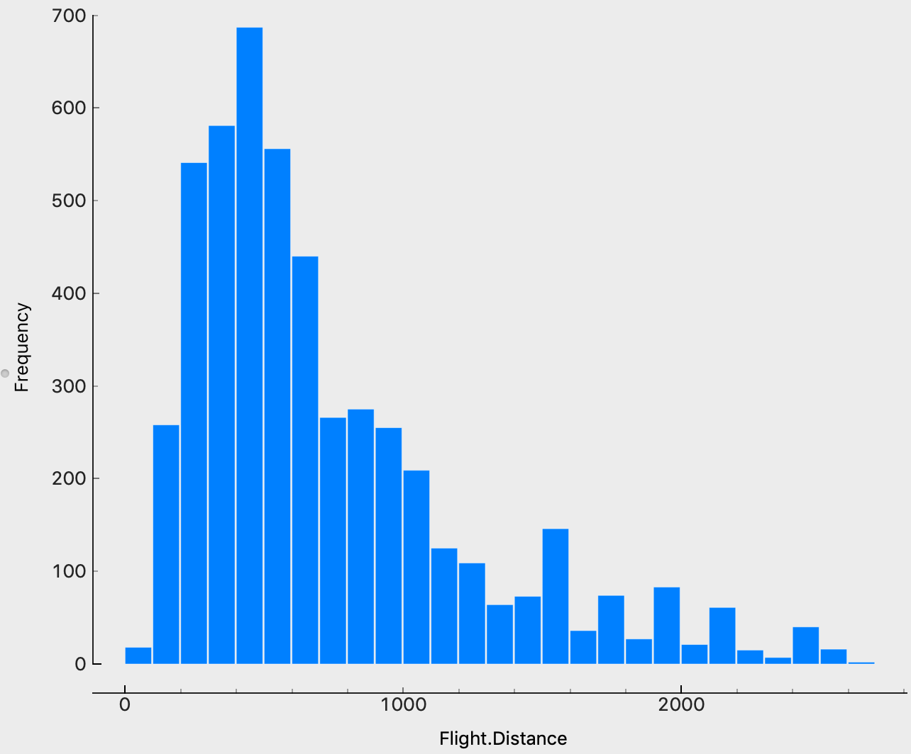

The shape of histogram ispositively skewed (long right tail), most passengers had lower than 1000 flight distance.

## Likelihood to recommend

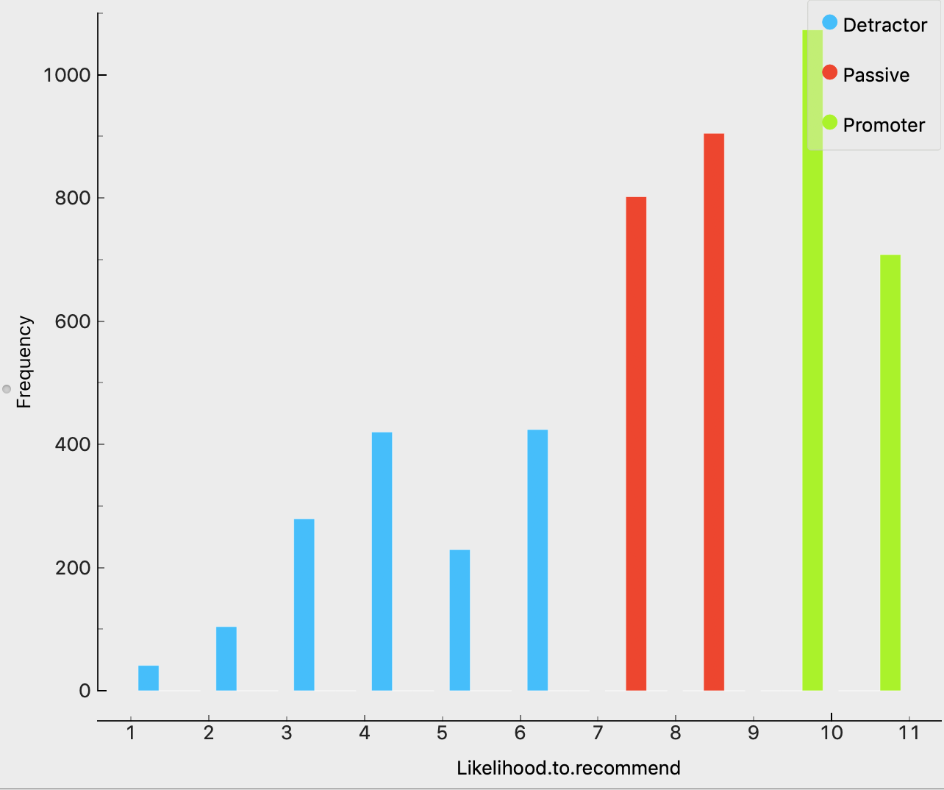

Attribute that was used to create the target category, we could see the shape of the histogram is negatively skewed (long left tail). Most passengers gave an over 7 net promoter score, some passengers gave an score from 4-6, only a few passengers gave an very low score(1-3).

# Exploratory Analysis

## Segment

We discretized all the numeric attributes in the data set into 5 equal-width sets, and then chose Partner.Name, Gender, Age, Class, Type of travel, Loyalty, Price Sensitivity to build the k-means undirected data mining model with 5 clusters for each category.

## Detractors

We found that Age was an interesting variable, people whose age more than 60 tend to be the same cluster. In addition, people whose Loyalty was lower than -0.5 were in the same cluster.

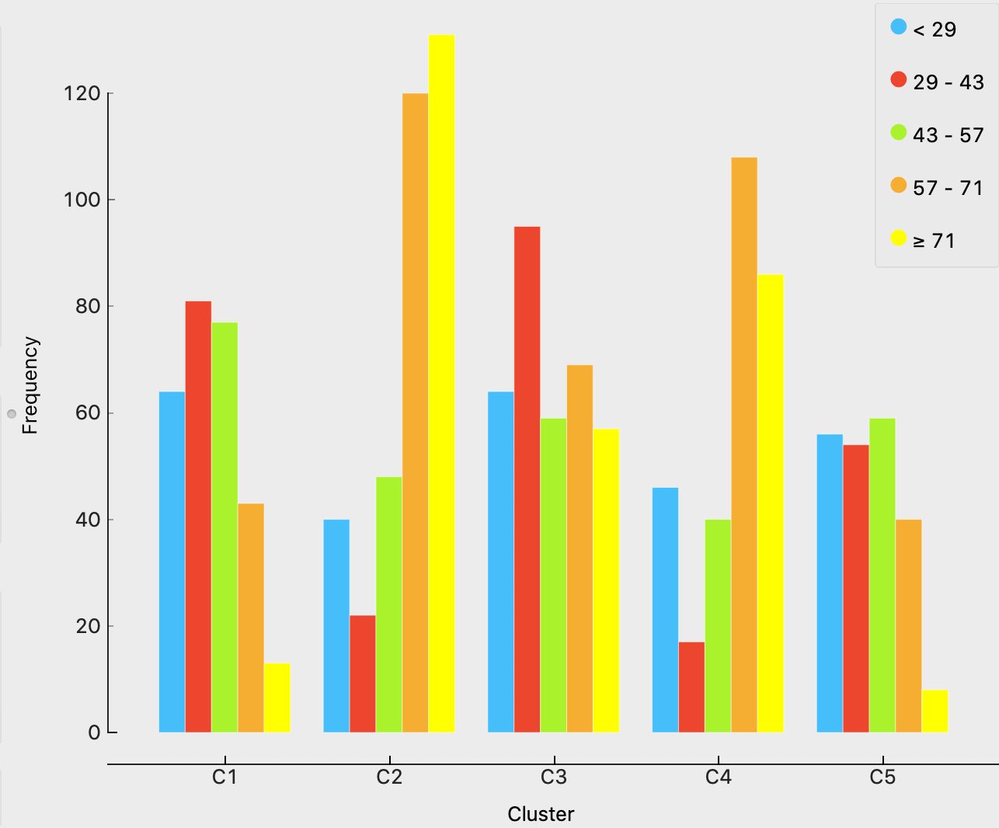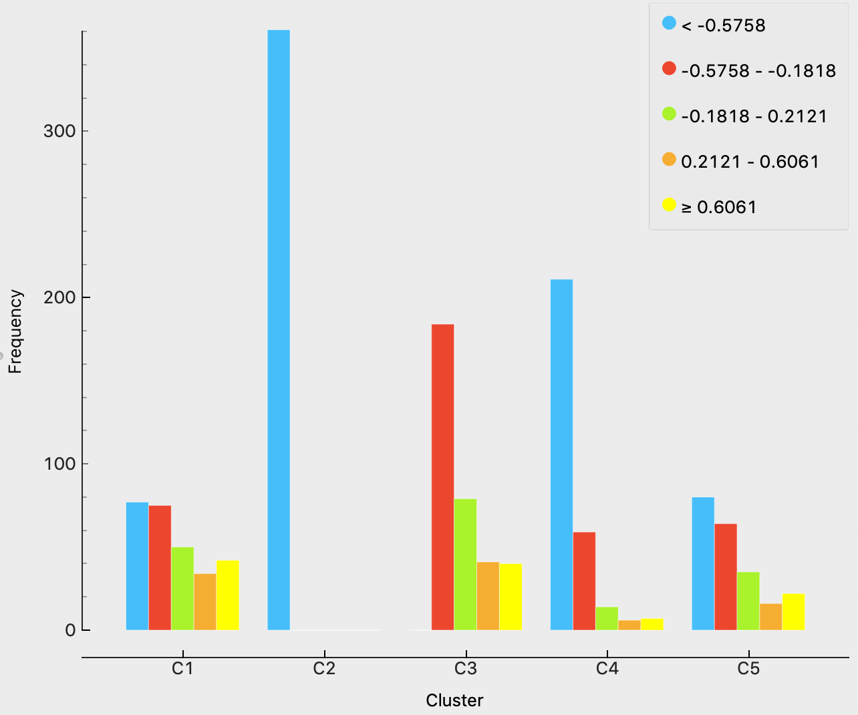

Business travel and personal travel showed much difference. So did the gender, male and female were put into different clusters.

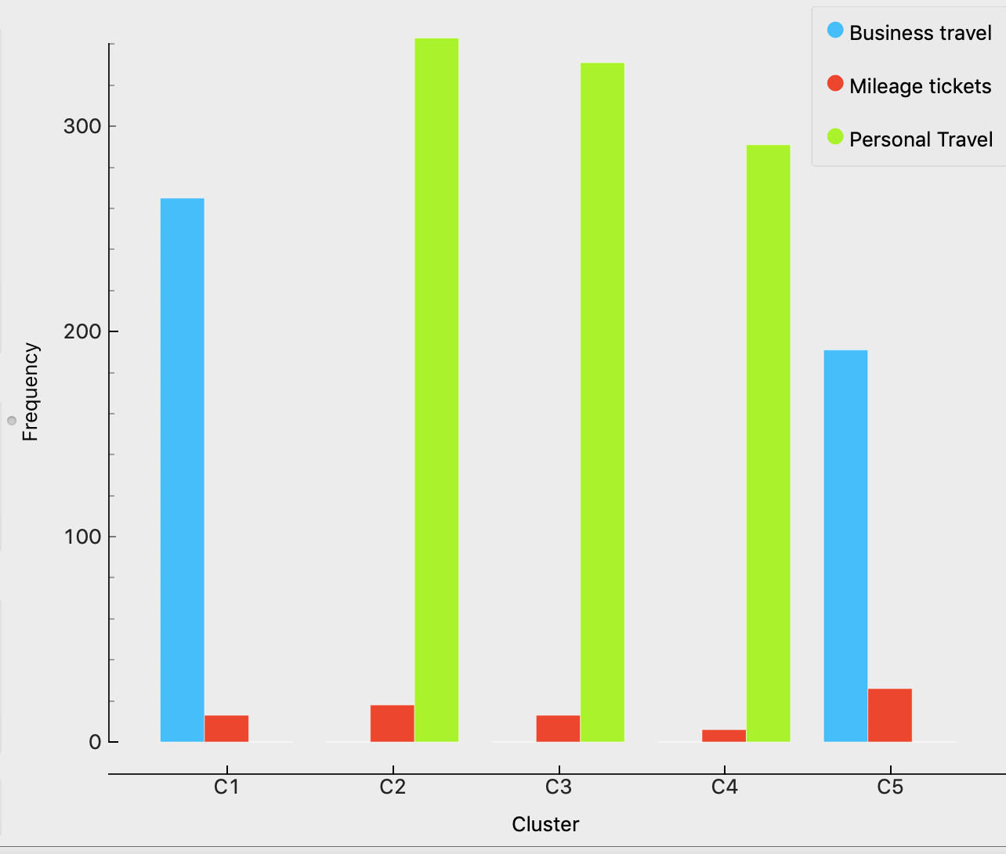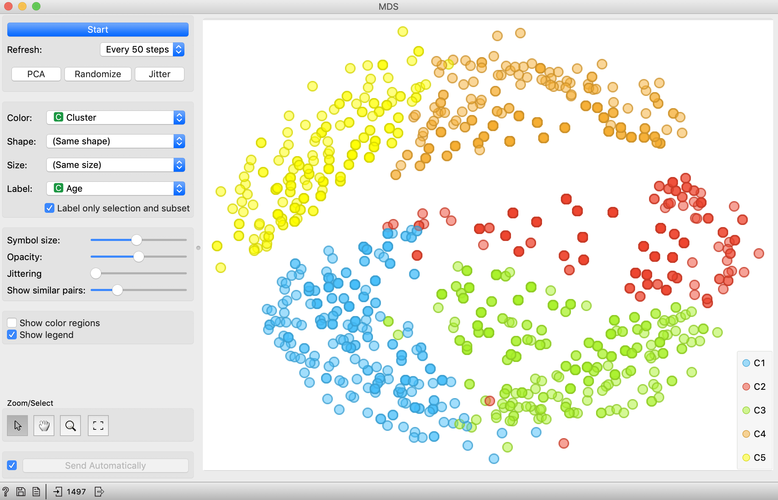

## Passives

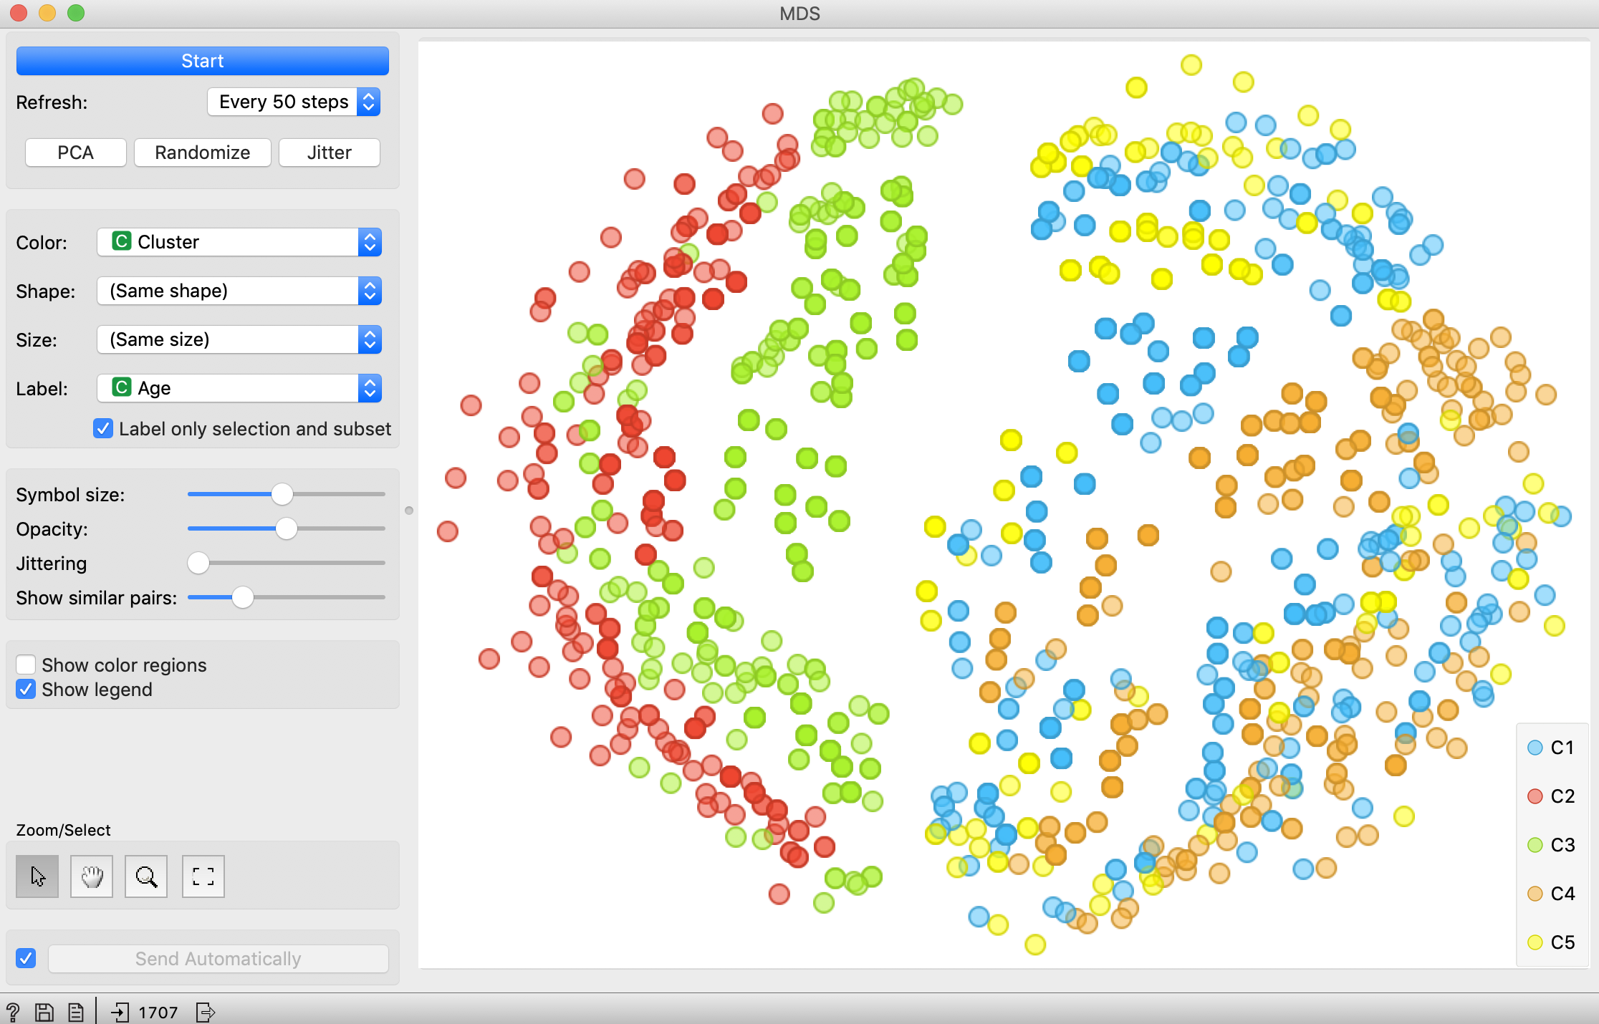

In the Passives category, *Cheapseats Airlines Inc* tended to be in one cluster. And gender would be a meaningful segmentation variable.

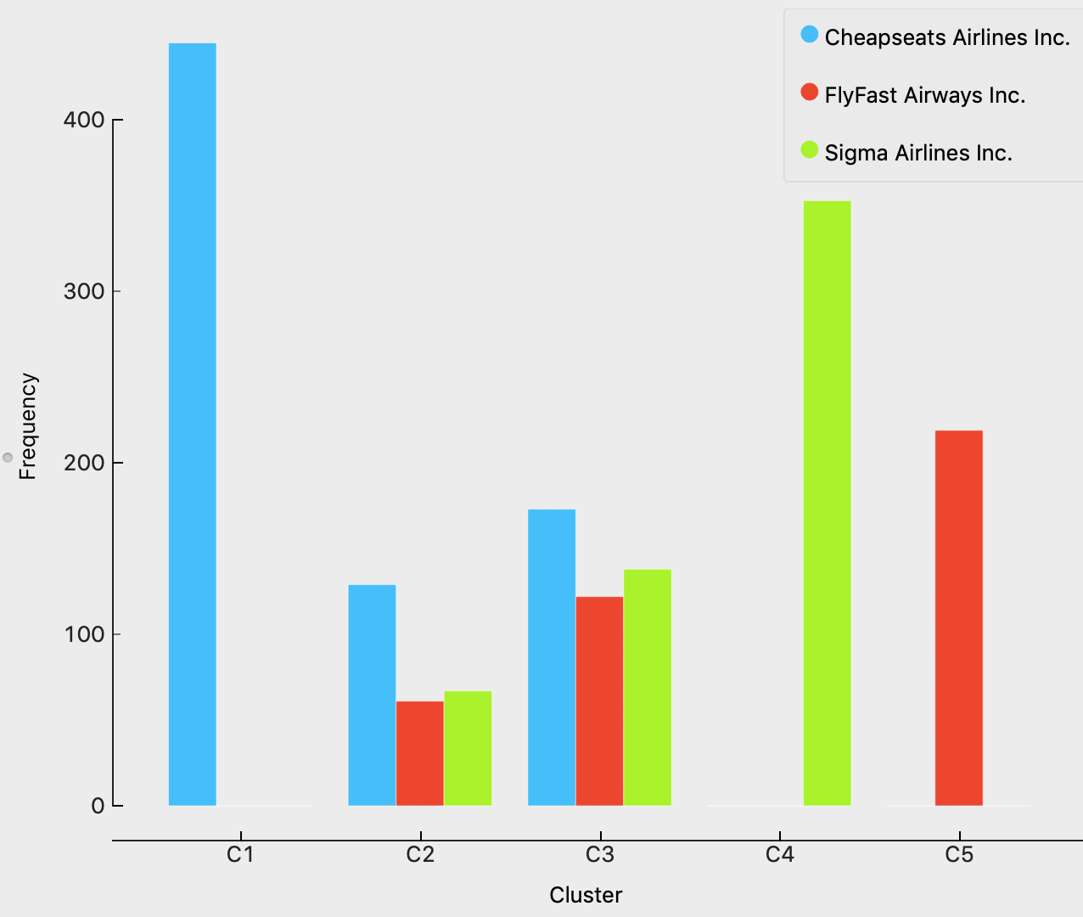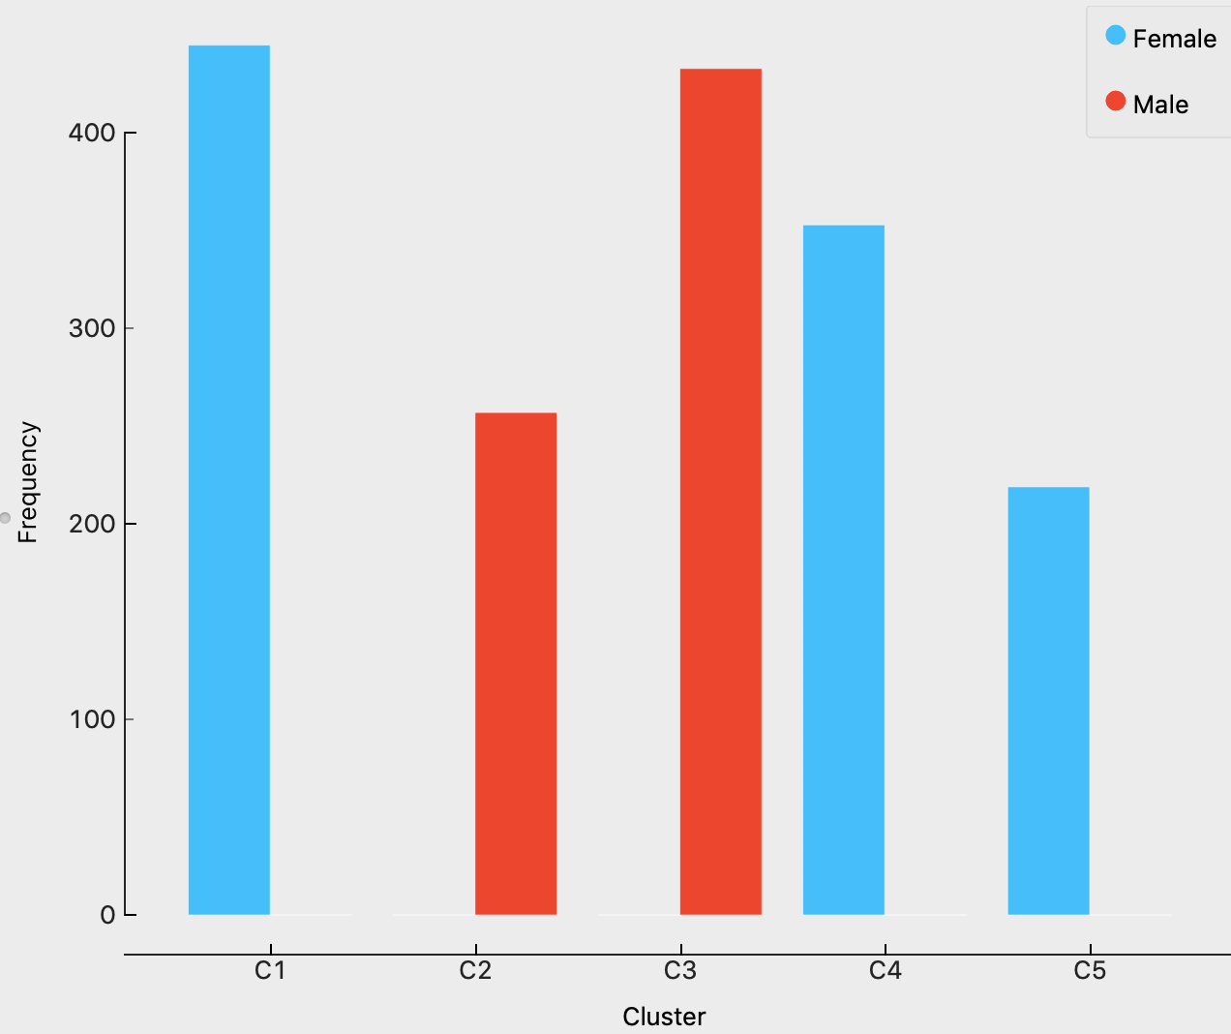

## Promoters:

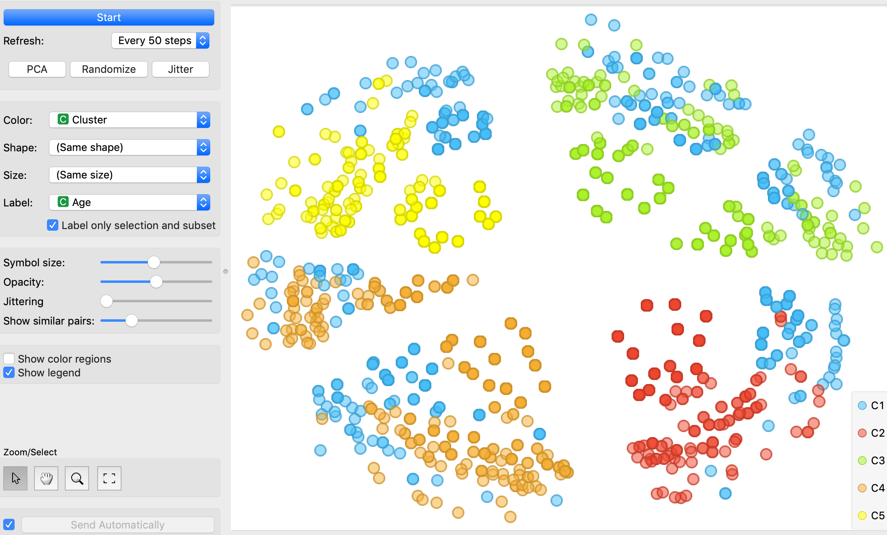

In the Promoter category, Cheapseats Airlines Inc and Sigma Airlines Inc showed differences with FlyFast Airways Inc. For Price Sensitivity, passengers with high sensitivities were different with others.

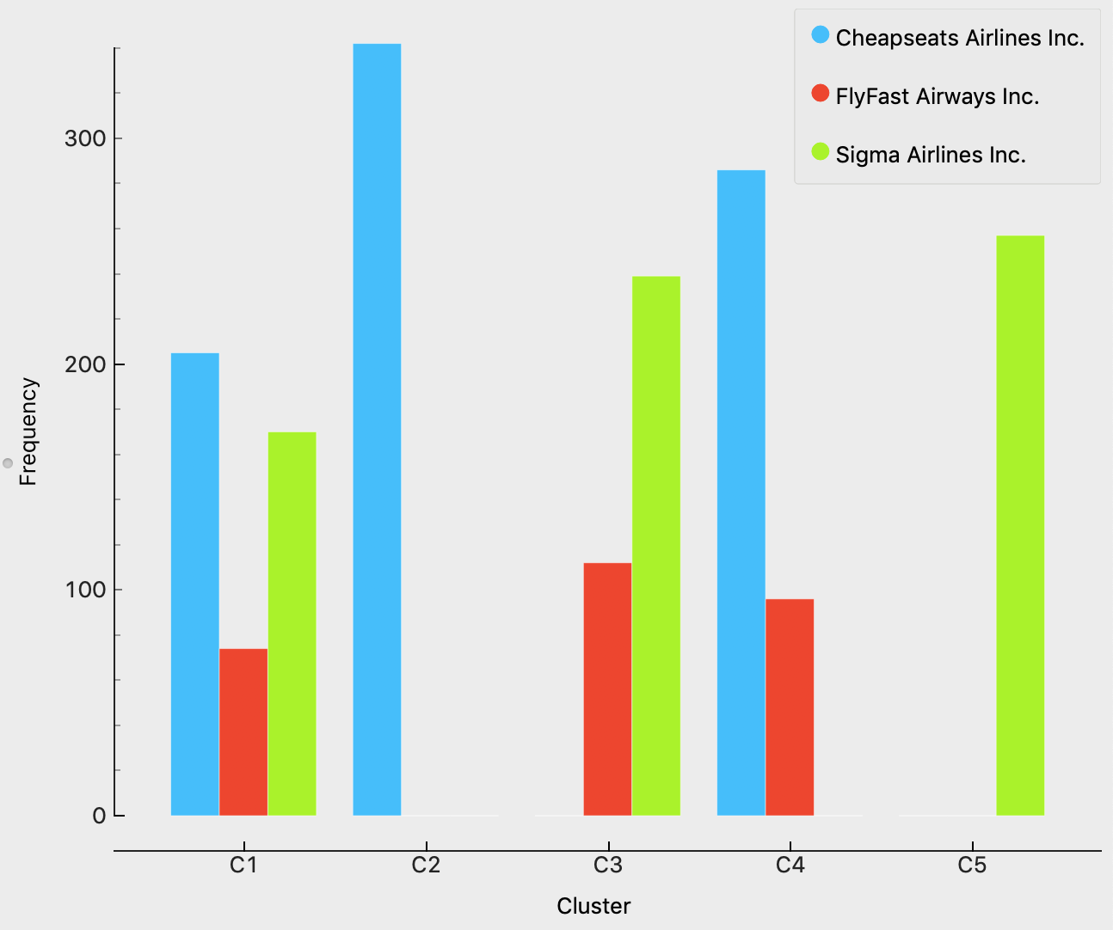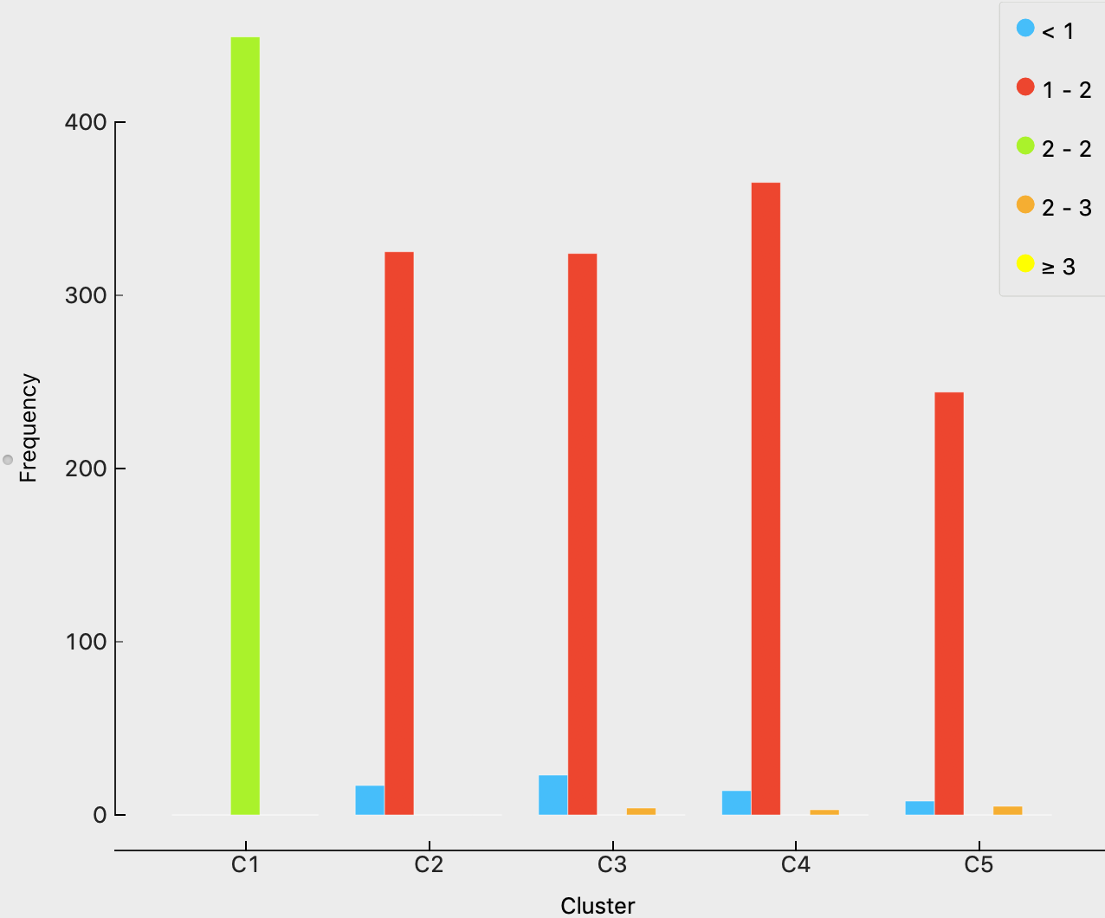

## Different variables in segments

Besides, to get a good market segmentation, we also chose to take a look at each variable’s box plot.

For *Age* variable:

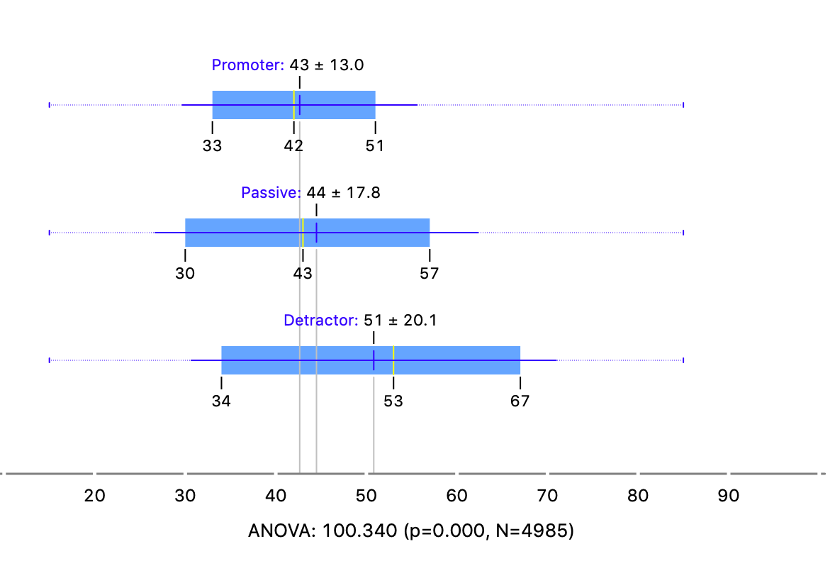

We could see that the mean age of *Detractor* was 51, while the other two categories were at around 43.

For *Loyalty*, from box plot we could get a basic inference that passengers with lower loyalty scores tended to give a lower nps score.

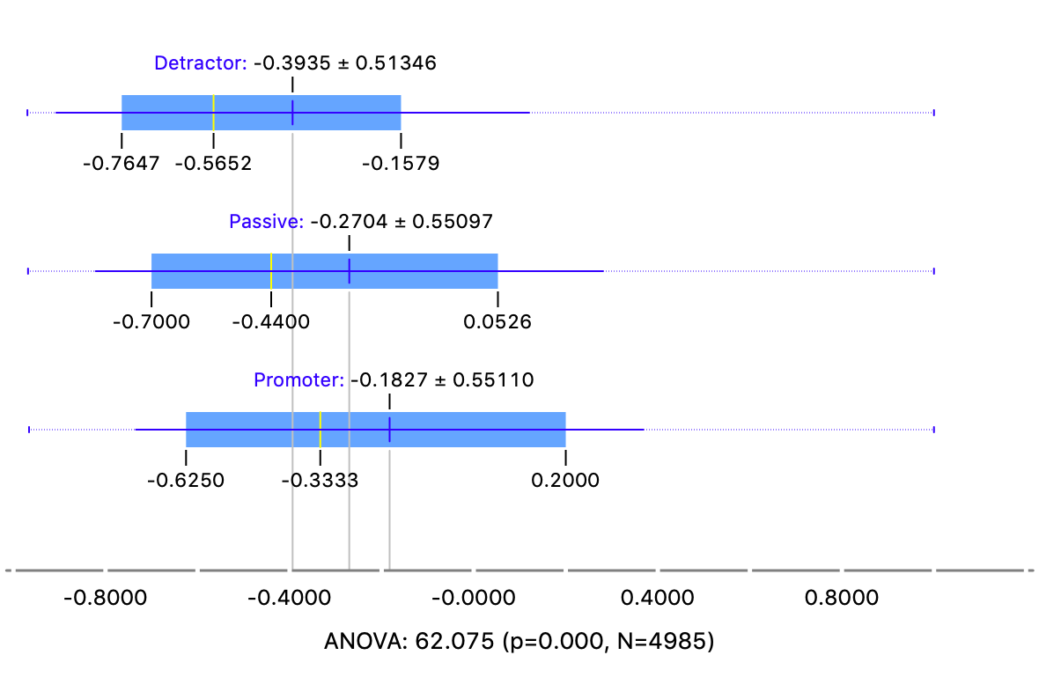

From box plots of Flights Per Year, Flight Distance, Total Freq Flyer Accts we could get the information that those passengers with rich flight experience were more likely to have a higher NPS score.

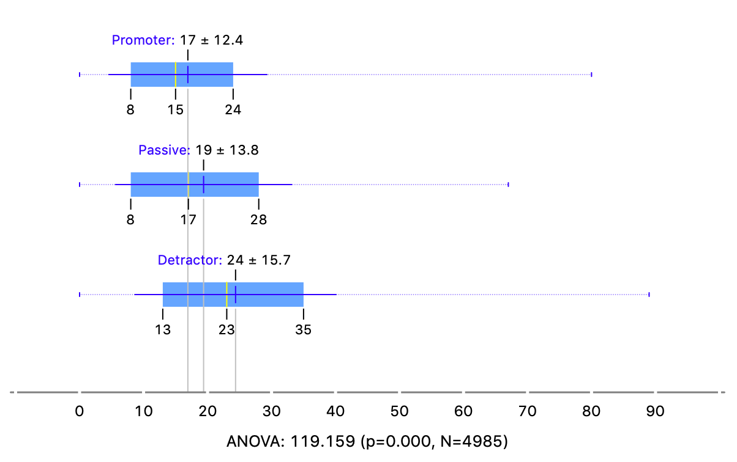

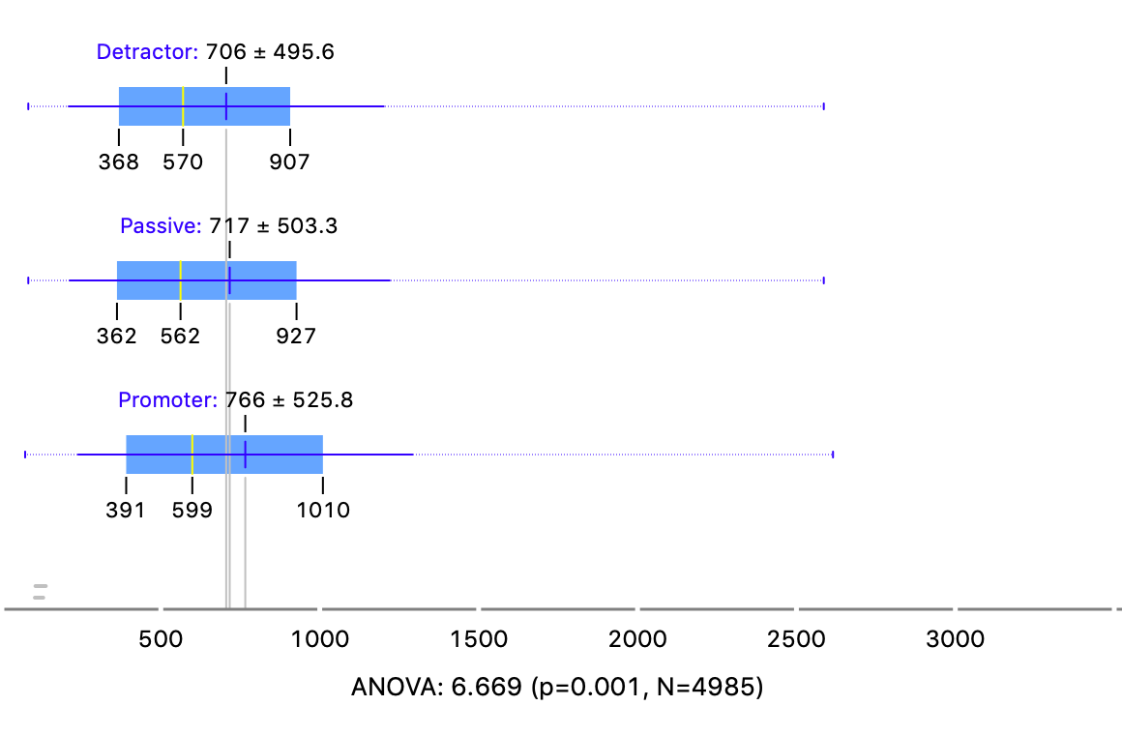

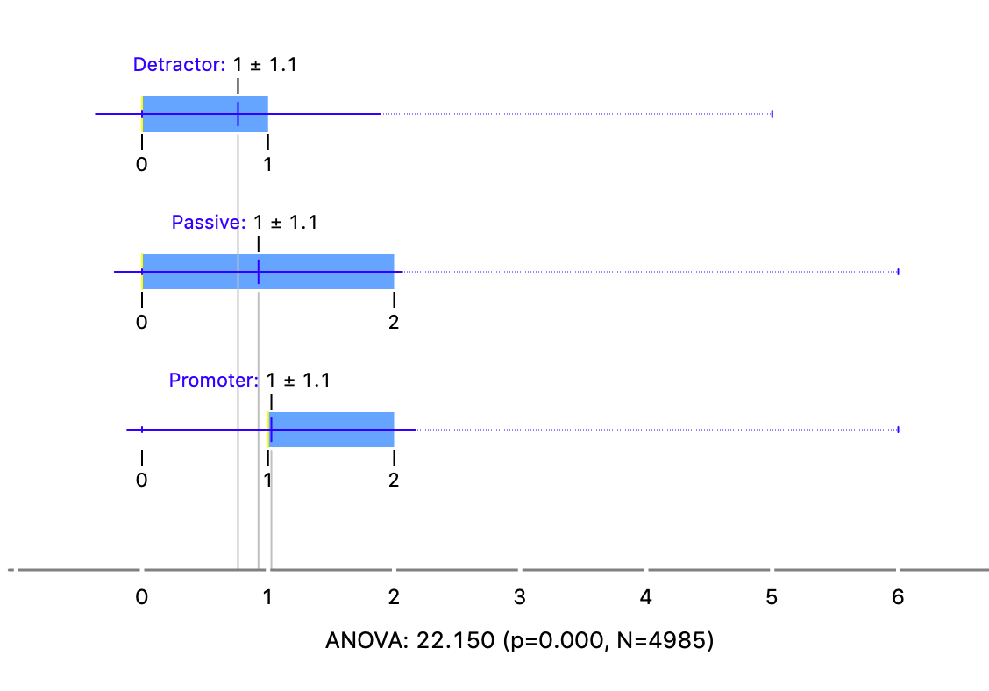

## Conclusion of segmentation

Combined the histograms, box plots and the results of the k-means model, we considered segmenting the customers using different attributes for different categories.

For detractor, we considered using *Age, Gender, Loyalty, Travel type* attributes to segment the customers.

For passives, we considered using *Gender, Partner Name, Class* to segment the customers.

For promoters, we considered using Gender, *Partner Name, Price Sensitivity, Flight per year to segment the customers.*

## Sentiment Analysis

*Sentiment Analysis.* About 275 of the survey responses have comments. Isolate those surveys with comments, and develop a word cloud that identifies the key themes associated with positive and negative sentiment.

According to the result of our segmentation and visualization, we decided to do the sentiment analysis based on *partner name*. And the sentiment analysis working flow is shown as follows.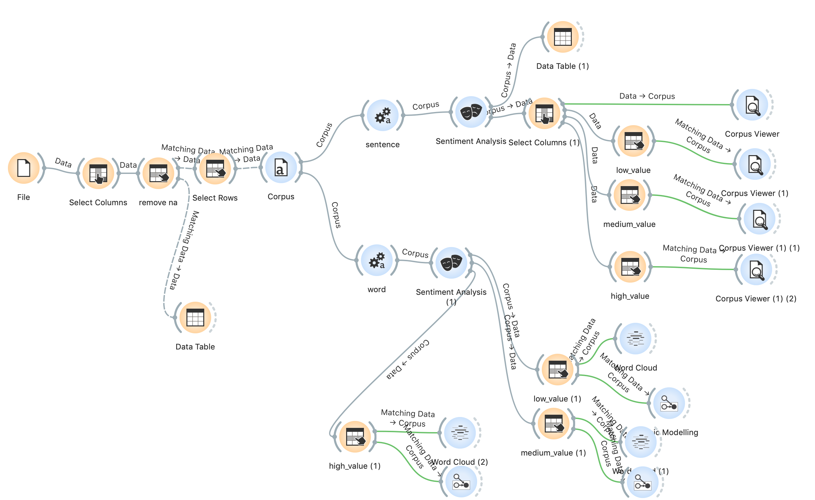

Firstly, we removed all the NA value in the *freeText* meta attribute using the *Select Rows* widget. Then we chose the *Cheapseats Airlines Inc*. After filtering, there were still 39 comments. Using these comments, we did the sentiment analysis on both sentence level and word level. In the word preprocess, we used the stopwords and lexicon to filter the words to get better results.

In the methods of sentiment analysis built in the Orange3, we chose the Liu Hu method since it would only produce one sentiment value which would be easier for us to do the analysis. While in vader method, it would provide three different kinds of values, but they are not so intuitive and our purpose is not to simply focus on those attitude values. After building our sentiment analysis model, we got a bunch of sentiment values, and we decided to analyze them in different groups, namely, high sentiment value (>2), medium sentiment value (-2~2), low sentiment value (<-2).

And we chose to use corpus *viewers* to show our results on sentence level, and we used *word cloud* and *topic modeling methods* on word level.

## Cheapseats Airlines Comments

Here are the results of *Cheapseats Airlines Inc*. comments.

1. Low sentiment value

Sentiment level

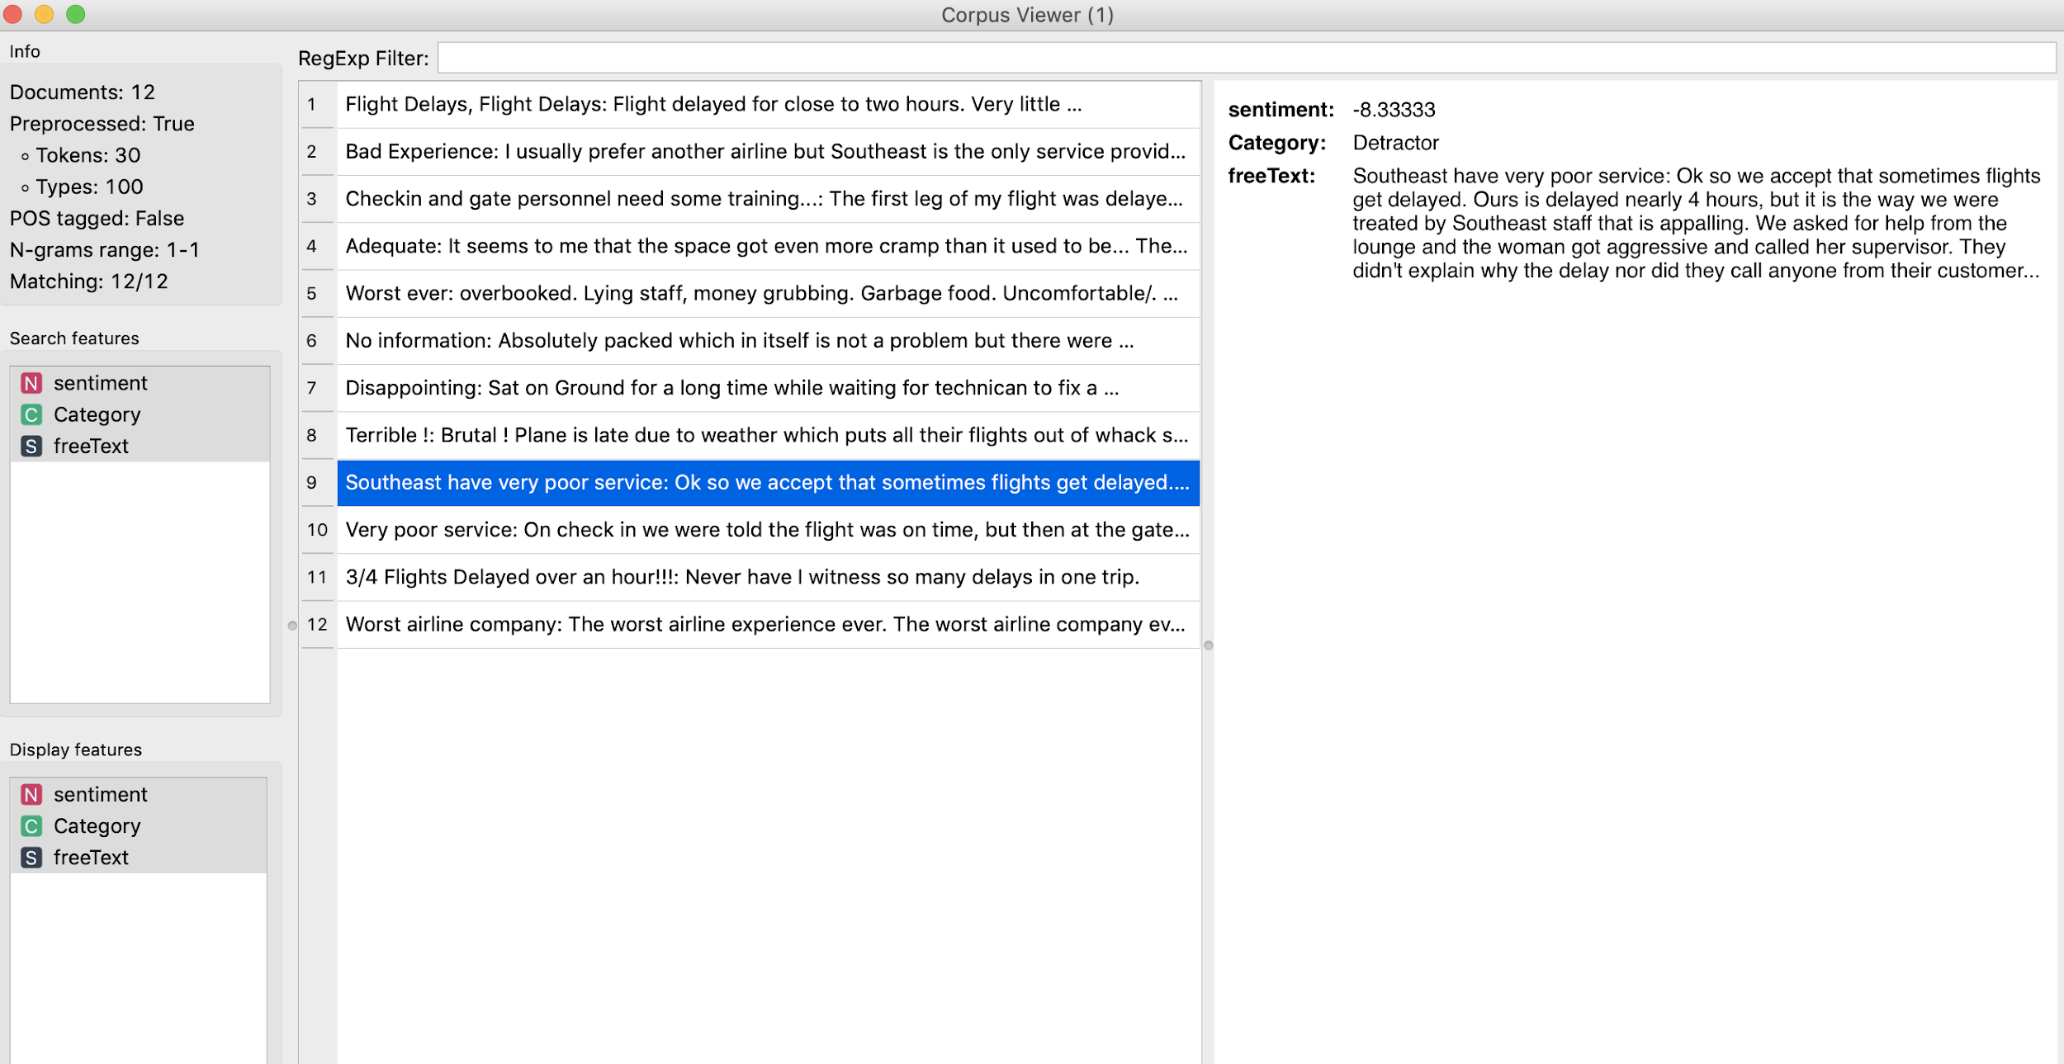

Word Cloud

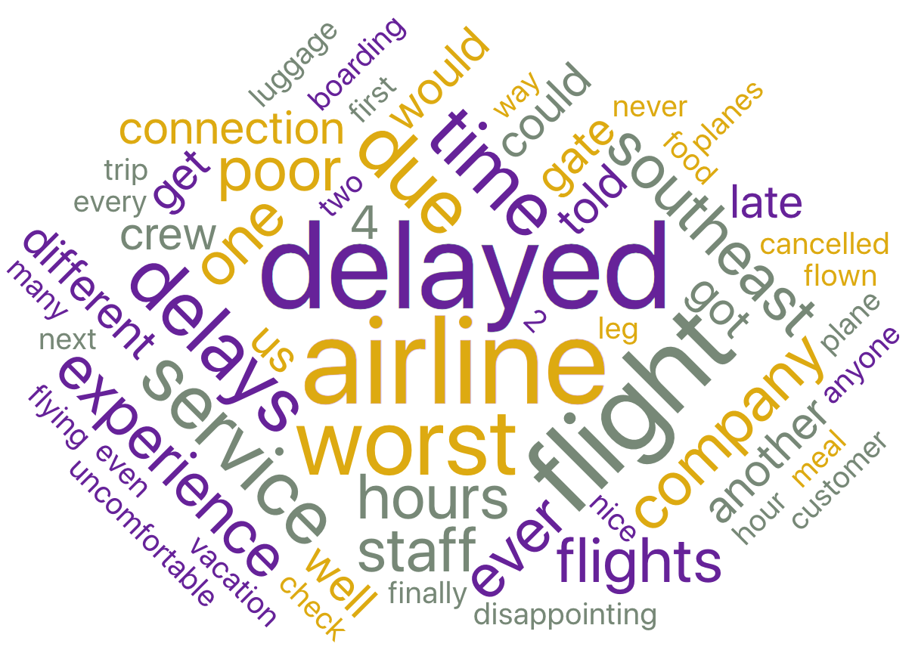

Topic Modeling

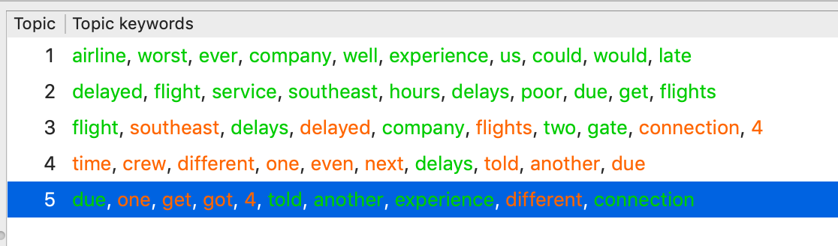

In the low sentiment value group, most reviews complained about the delay, and a few reviews contained uncomfortable and food quality. “Delay”, “worst”, “time” were the keywords.

1. Medium sentiment value

Sentiment level

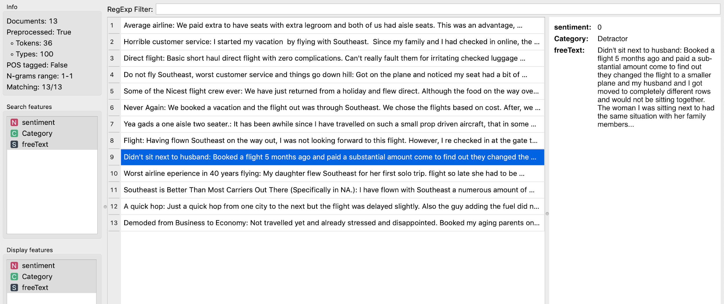

Word cloud

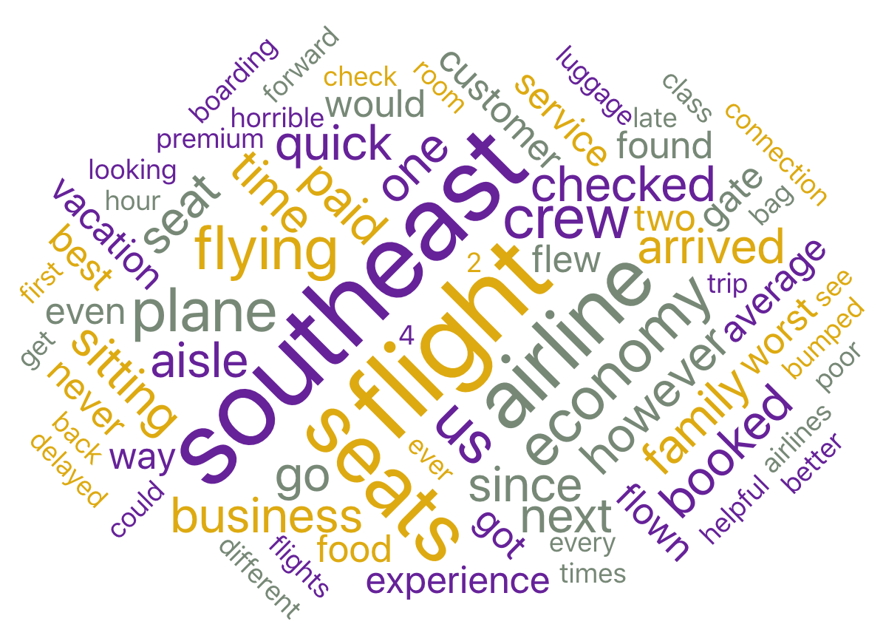

Topic modeling

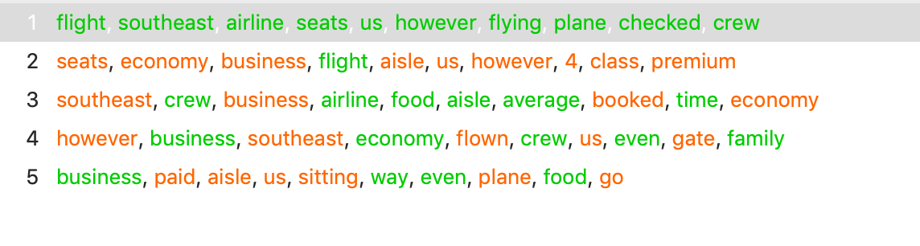

In the medium sentiment value group, most reviews were about customer service and some trifles and details that influenced the flying experience. “Southeast” was the most valuable keyword.

1. High sentiment value

Sentiment level

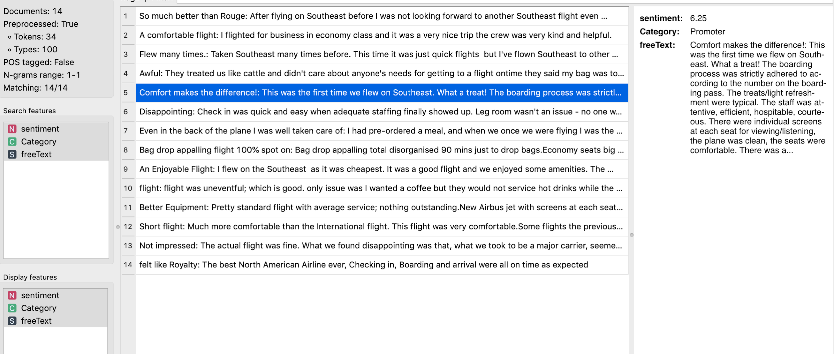

Word cloud

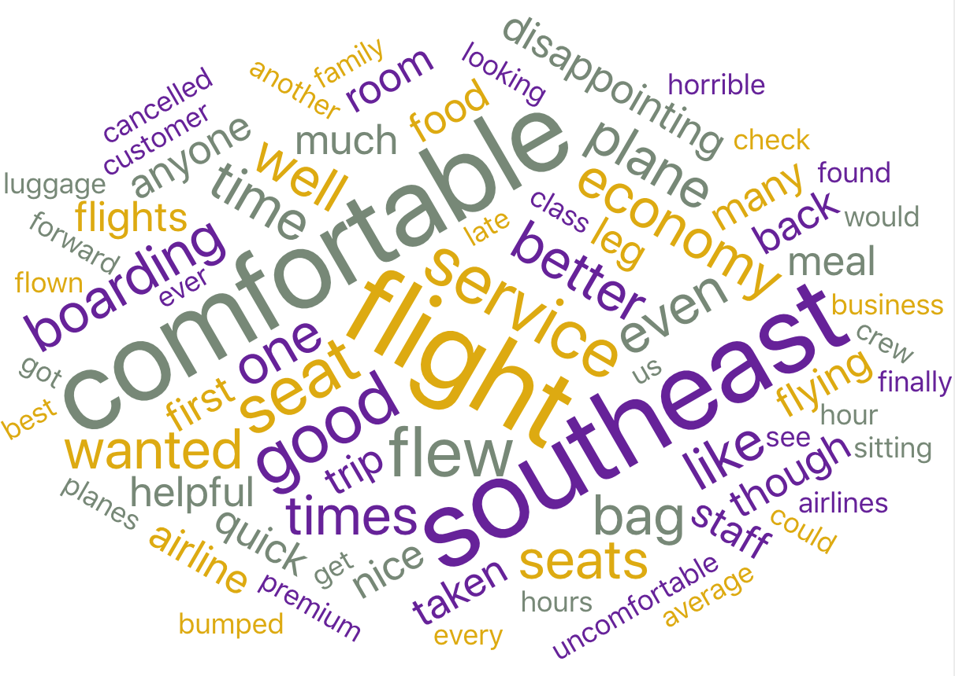

Topic modeling

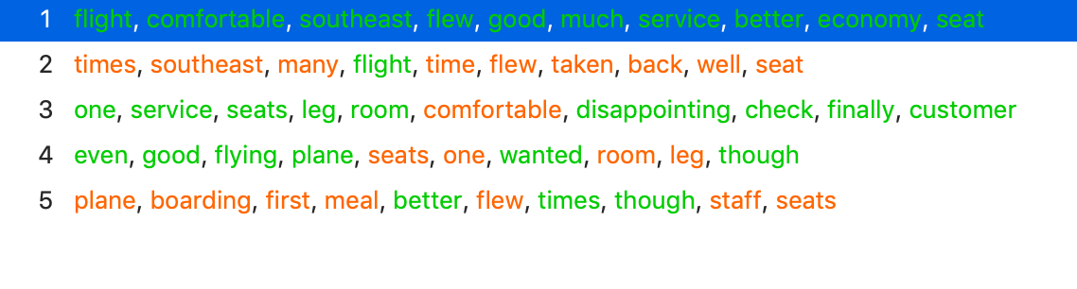

In the high sentiment value group, people talked about being treated well and comfortable. And most customers in this group were satisfied about their trip. “Southeast”, “Comfortable”, “Service” were the keywords.

## Other Partners Comments

After doing that, we did the nearly same thing to FlyFast Airways Inc. and Sigma Airlines Inc.

Due to space limitation, here we just showed the results we got from the sentiment analysis instead of putting each screenshot in the report.

For FlyFast Airways Inc. In the low sentiment value group, most people complained about the poor service and equipment in the plane and the delay. In the medium sentiment value group, seats and luggage were mentioned a lot, people in this group seemed to be not satisfied with charging for seats and poor service for luggage. In the high sentiment value group, people talked about the nice service and the plane’s due arrival.

For Sigma Airlines Inc. In the low sentiment value group, most people complained about the poor service and wasted time. In the medium sentiment value group, narrow seats and poor service during the trip were mentioned. In the high sentiment value group, same as the other two companies, people were satisfied with the comfortable seats, good service and without delay.

Besides the segmentation on different airline companies, we also did the segmentation for the *type of travel*. Here are the word clouds (left:Business, right: others)

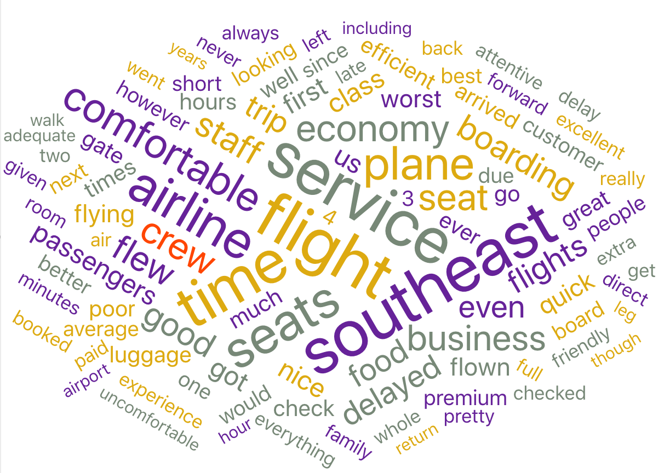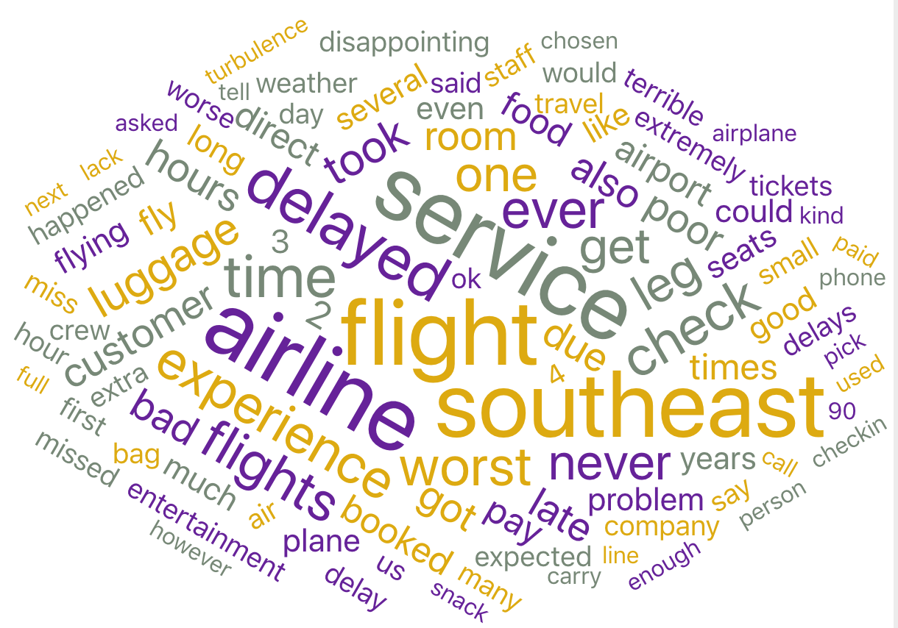

The difference is that business people tended to care about the comfort more, while the other people cared about delay more. But what we really got from the analysis is that people mentioned the southeast, delay and service in both types of travel, which means that maybe we could improve the nps score for different types of travel by the same way (focusing on the factors that everyone cares about).

## Predictive Modeling

Our purpose of this project is not to get a perfect prediction model but to get actionable and intuitive insights from our model. So what we would do is to build different models to predict the NPS category by segment rather than the whole dataset.

## Random Forest

In this phase, random forest was our first model to build.

A Random Forest is essentially a collection of Decision Trees. A decision tree is built on an entire dataset, using all the features/variables of interest, whereas a random forest randomly selects rows and specific variables to build multiple decision trees from and then averages the results. The random forest algorithm doesn’t require complicated preprocessing of our data but has a relatively good prediction performance. So that’s why we chose this algorithm to begin with.

First of all, we removed the *Flight.Date* column and the Likelihood to recommend column which would not be useful for the models we chose. Then, to build the random forest model, we did a 5 intervals equal-width discretization to all the numeric variables. We set the random forest model with 50 trees, chose the option of “do not split subsets smaller than 5” and chose the 10 folds cross-validation in test and score widget.

After preprocessing the data and basic setting of our model, we built several random forest models on different segmentations based on our former discussion.

1. Using all data:

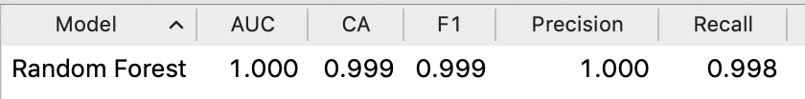

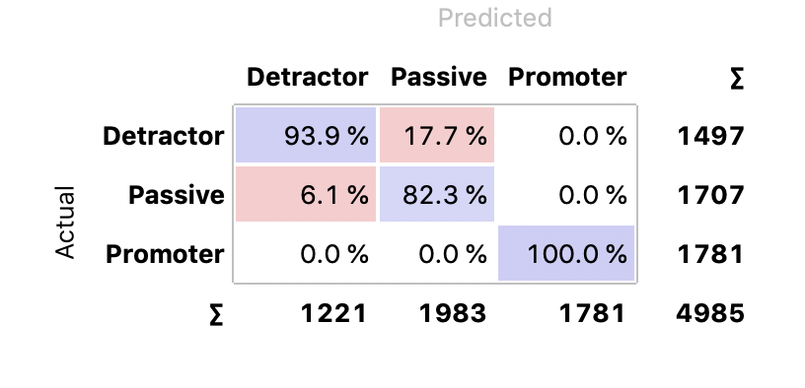

We got a pretty good performance model using all data. Then we used the *Score Genes* widget to check the variance importance.

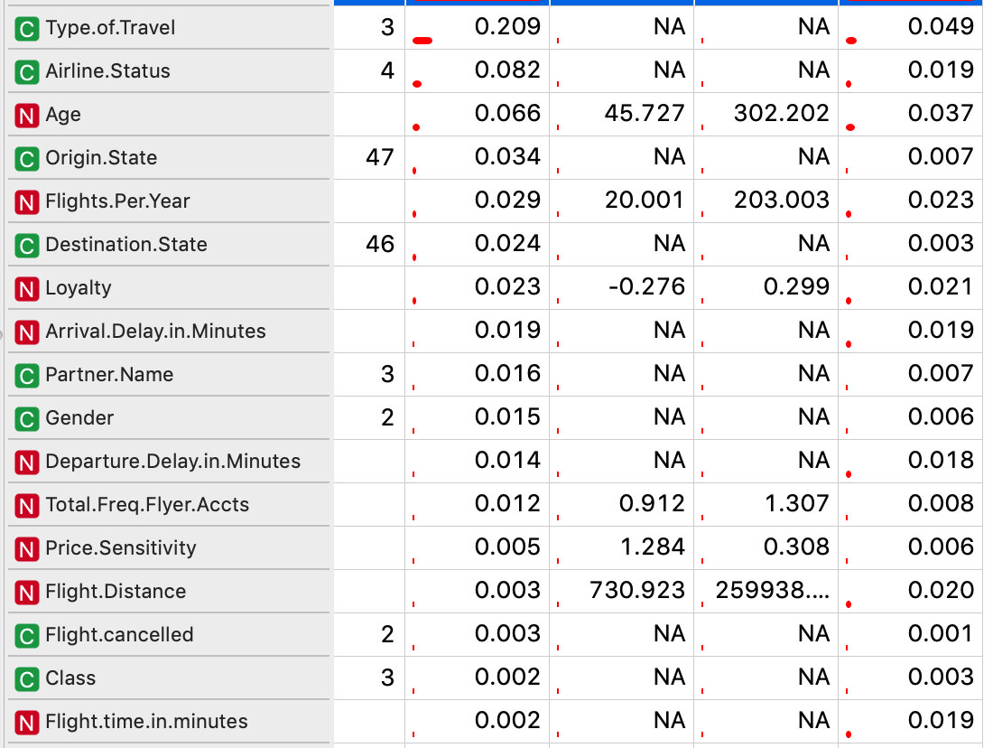

We could see that *Type of Travel, Airline.Status, Age* were the top 3 important variance.

1. Model on different types of travel:

* Business travel:

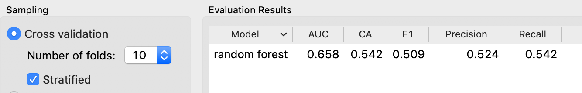

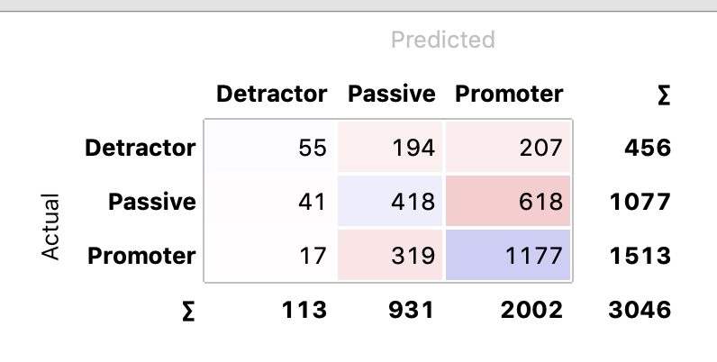

* Mileage Tickets:

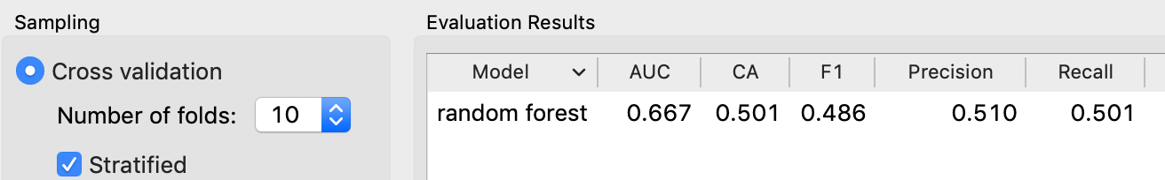

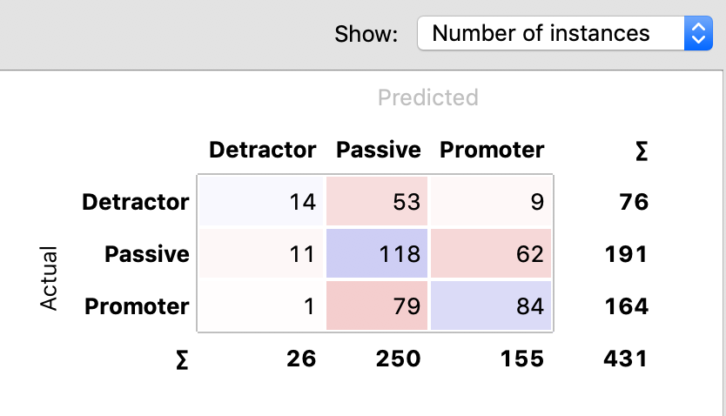

* Personal Traveling:

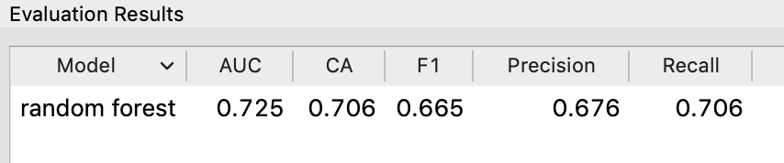

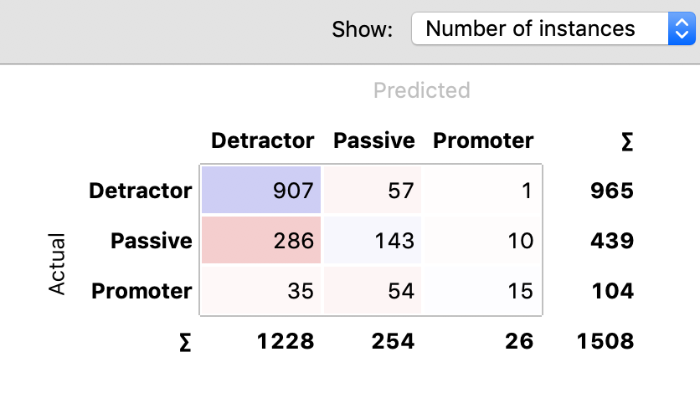

## Naive Bayes

A Naive Bayes classifier is a probabilistic machine learning model that’s used for classification tasks. The crux of the classifier is based on the Bayes theorem. We classify which NPS segment, given the features of the customer. We assume that the predictors. For instance, if the flight is from Colorado, it does not necessarily mean that the destination is New York. In addition, we assume that all predictors have an equal effect on the outcome. That is, business travel does not have more importance in deciding to recommend. Naive Bayes algorithms are fast and easy to implement but their biggest disadvantage is that the requirement of predictors to be independent. In our case, the predictors are dependent, so naive Bayes is a good performance model for our project.

Here to build the model, we also did the data preprocessing including imputing, discretizing, and feature selection with information gain more than 75%.

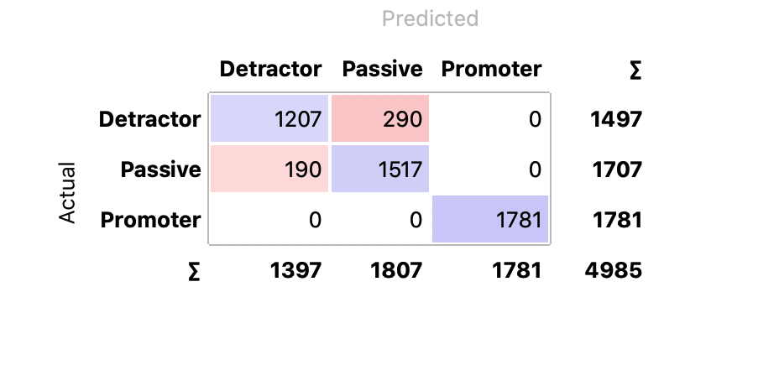

After modeling, we got a pretty good performance. Not so perfect as the random forest did, but also had a high precision, recall and f1 score.

## Support Vector Machine(SVM)

The objective of the support vector machine algorithm is to find a hyperplane in an N-dimensional space(N — the number of features) that distinctly classifies the data points. But the support vector machine is mainly used to set binary classification. So a support vector machine is not a good model for our case.

Another reason that SVM may not be suitable is that SVM is a linear model, while our data set has more than 15 attributes, including different data types, different fields of data, which means the relationship between those attributes and target variable is not likely to be linear.

After data preprocessing, we built a default SVM model. From the result we could see the performance was not good, and we did not try further tuning since it performed poorly at the first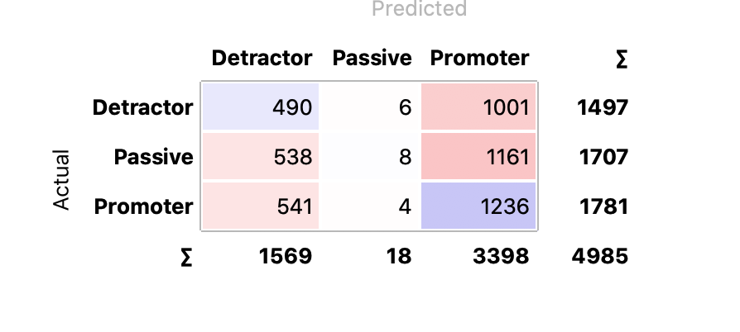

## K-nearest Neighbors(k-NN)

KNN (K — Nearest Neighbors) is one of many supervised learning algorithms used in data mining and machine learning, it’s a classifier algorithm where the learning is based on “how similar” is a data (a vector) from others.

In our case, certain types of our customers are more likely to give the same NPS score. For example, those who give a low NPS score and become a detractor may have the same reason. In other words, if a data is similar to another data, they may have the same value on the target variable.

So we built a KNN model with 5 neighbors, ‘Euclidean’ metric and ‘Uniform’ Weight.

Here are the results.

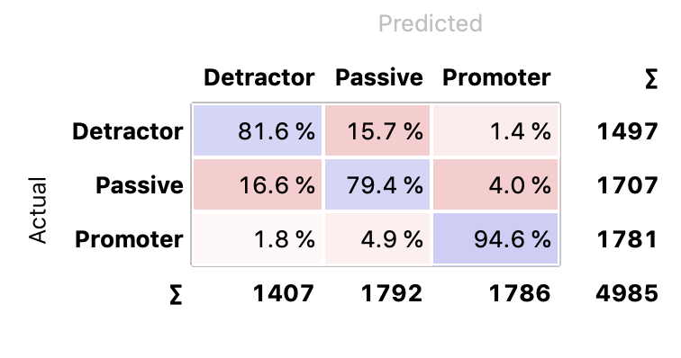

## Neural Network

Neural networks are a set of algorithms, modeled loosely after the human brain, that are designed to recognize patterns. Those network algorithms now are widely applied in nearly each field, especially artificial intelligence.

As a deep learning model, the neural network is powerful and adjustable. The model is trained one layer by one layer, and we have a large number of data to support the training. We considered the neural network could bring a good performance just like random forest.

We chose the logistic activation function, 100 number of neurons in hidden layers and 200 maximum iterations.

Here are the results.

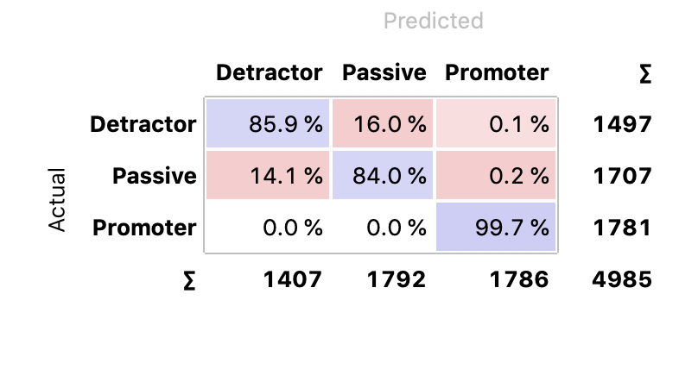

## Result comparison

**ROC curve(Detractor):**

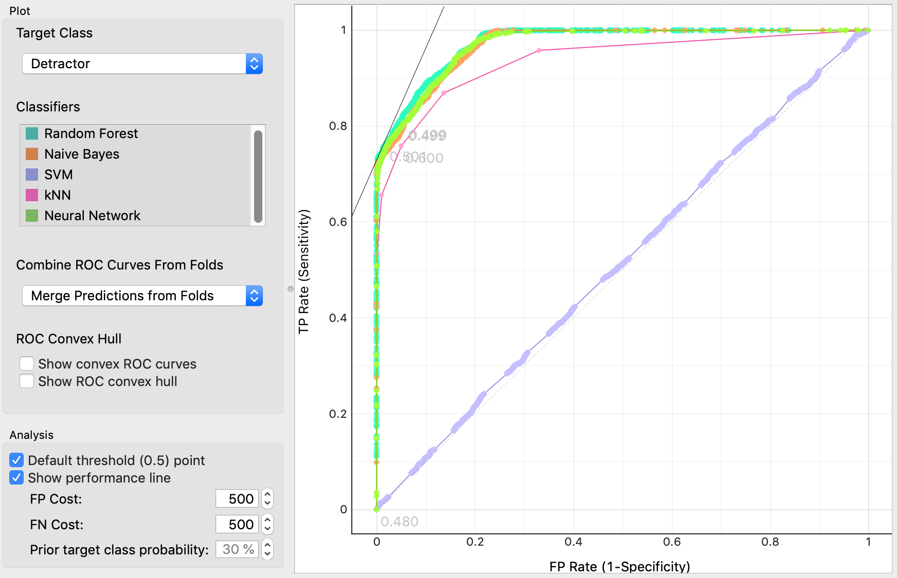

**Passive:**

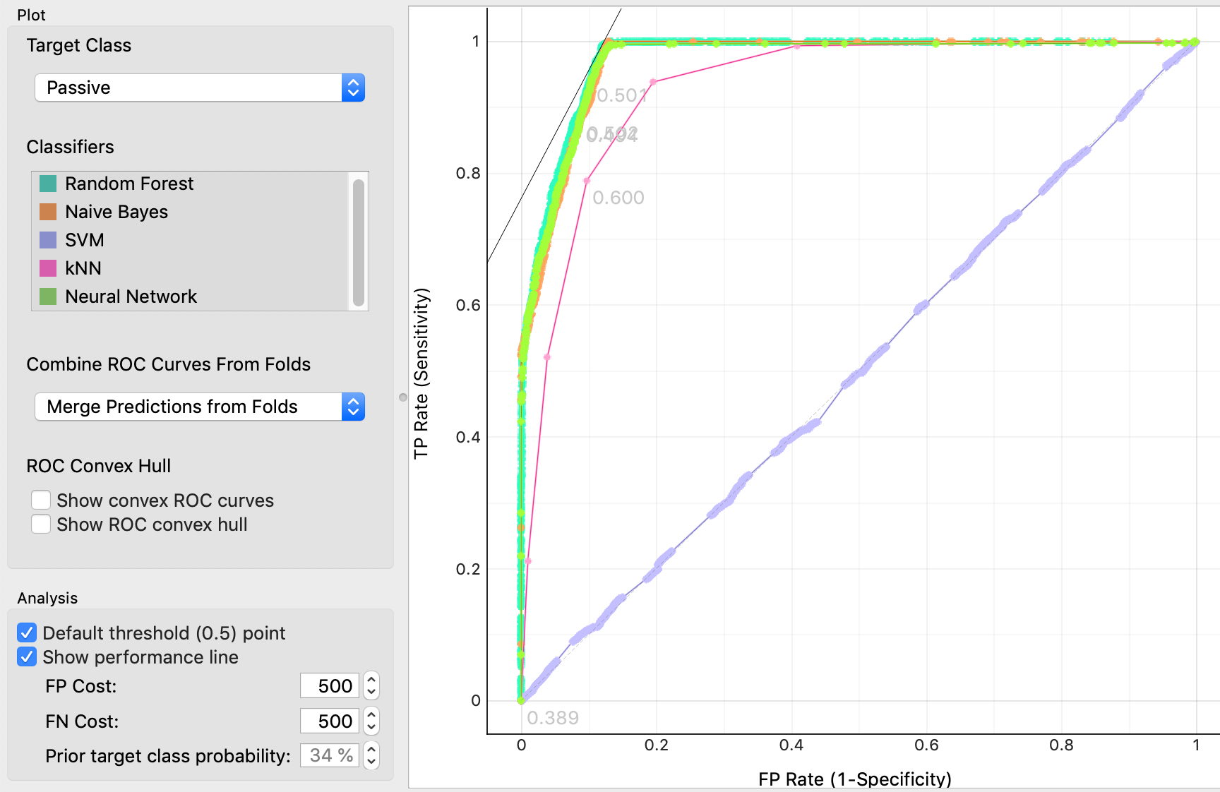

**Promoter:**

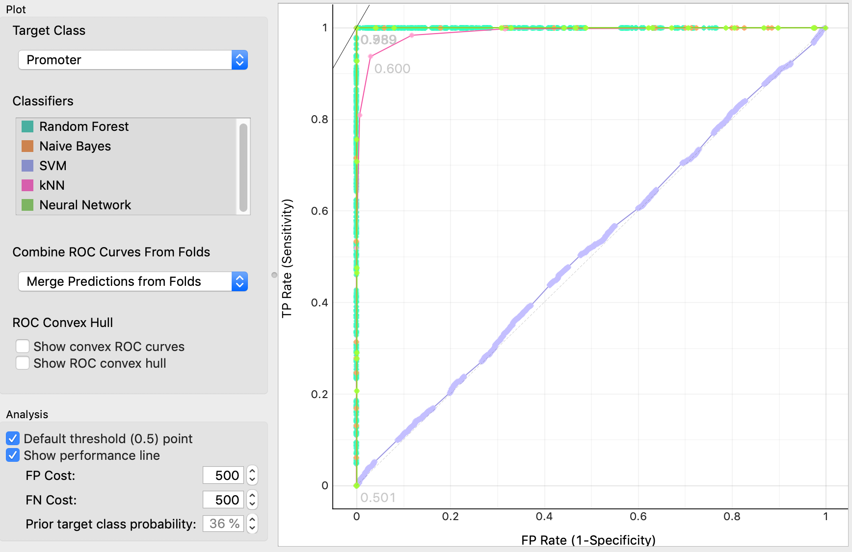

**score:**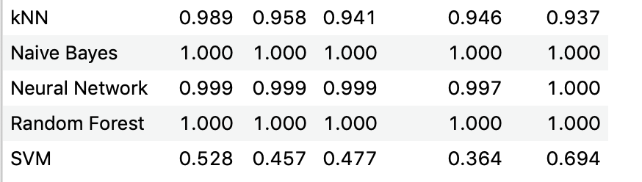

From the ROC curves, we could see that the svm performs the worst, almost the same as random choice. All other algorithms perform pretty well, especially the random forest and neural network. Combined with the scores and earlier confusion matrix, in predicting the detractors target, the random forest works the best.

Based on the comparison, we finally chose the random forest model as our best predictive model to apply on the customer data since this model performs the best and it could help us gain insights about feature importance.

# Business Recommendations Development Phase

## Business Analysis

Our client (FastFlyAirways) wants to know why they have such a high percentage of Passives and Distractors. To find out the reason, we used our best model to predict the customer data, did some visualization and compared the results among those companies.

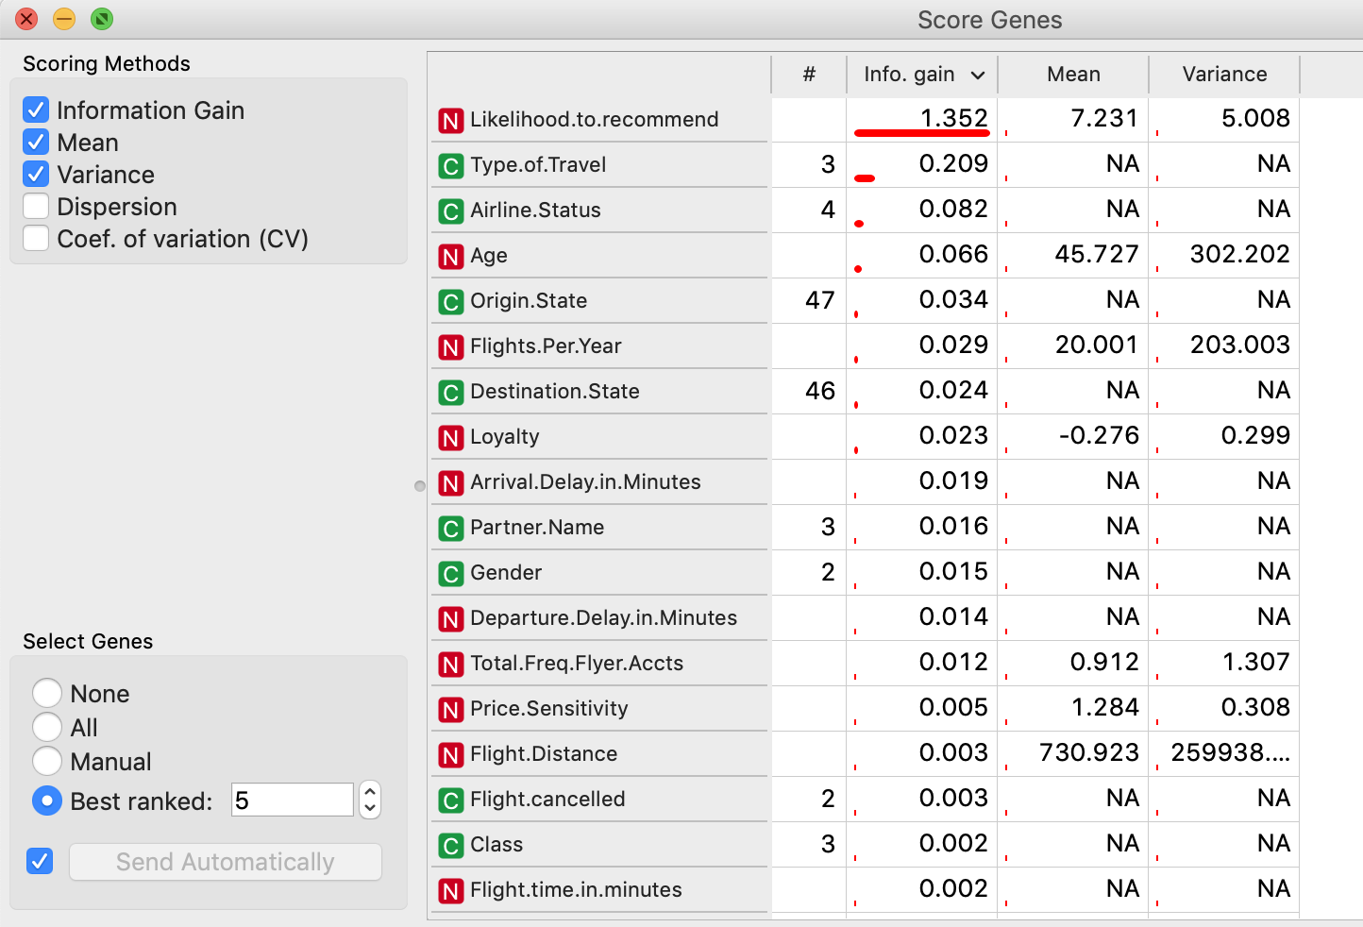

Combine the feature importance with the earlier discussion, we would do the analysis based on Gender, *Partner Name, Price Sensitivity, Flight per year, Travel type* to find the key factors to make a promoter and improve the satisfaction.

## FlyFast Airways Inc.

After we applied the model on our customer data, we got a data table with our predicted target (detractor, passive and promoter). Let’s take a look at the distribution of FlyFast company.

.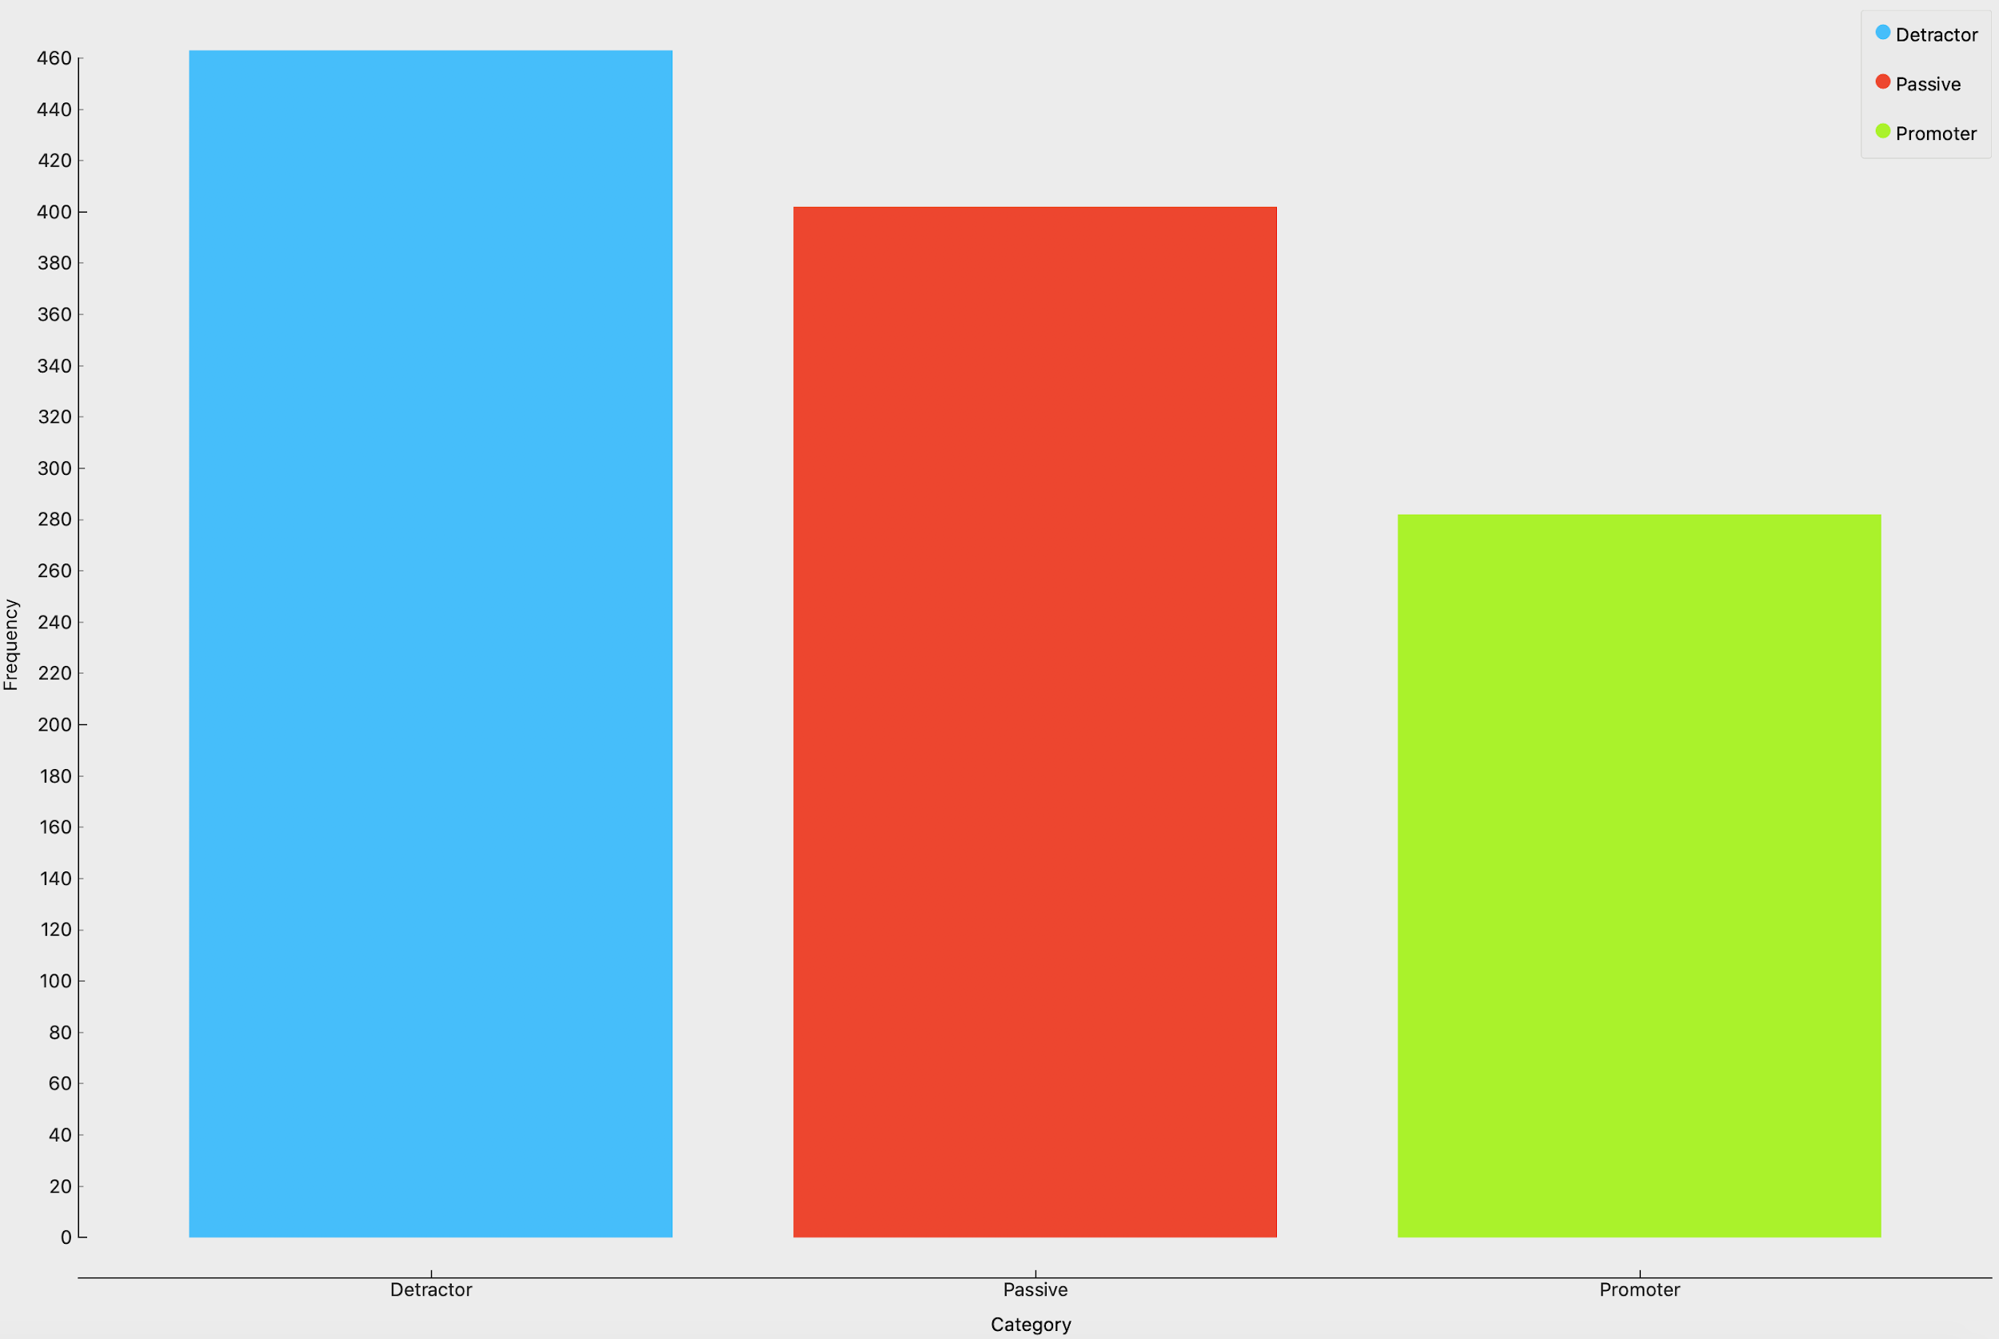

Most customers do not like to make recommendations . Then we did the segmentation.

1. **Type of travel**

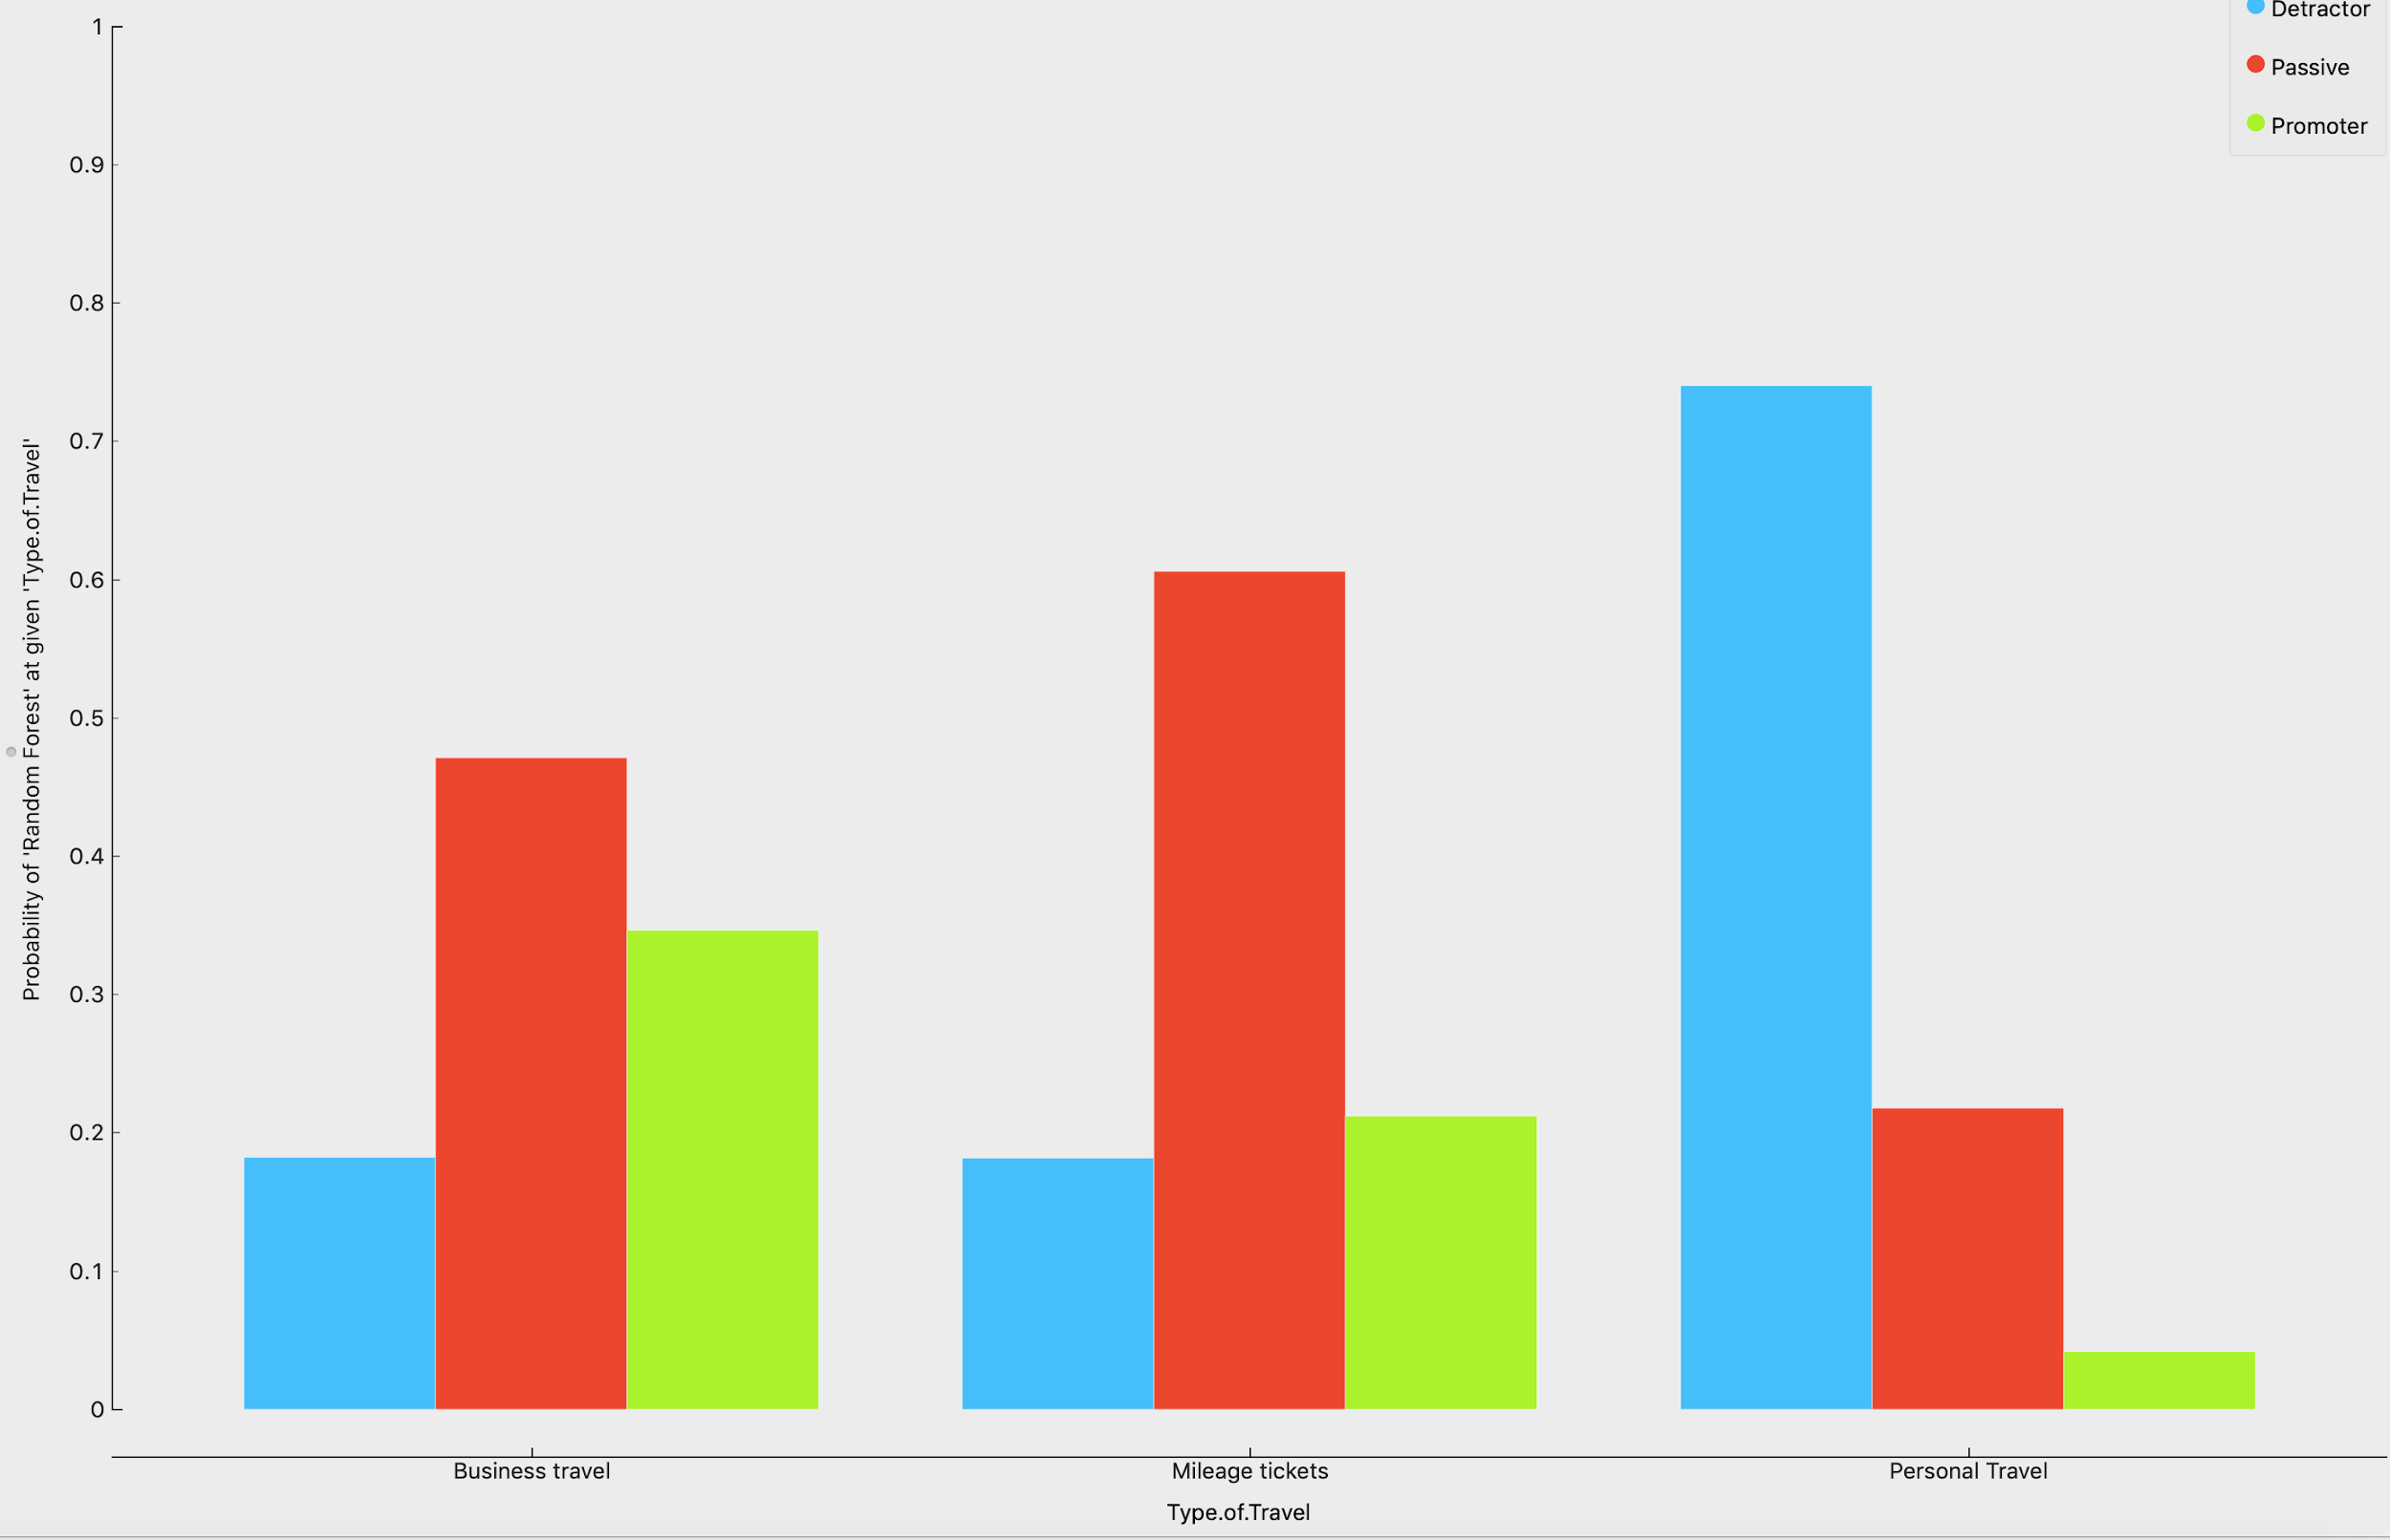

**(2)Flight per year**

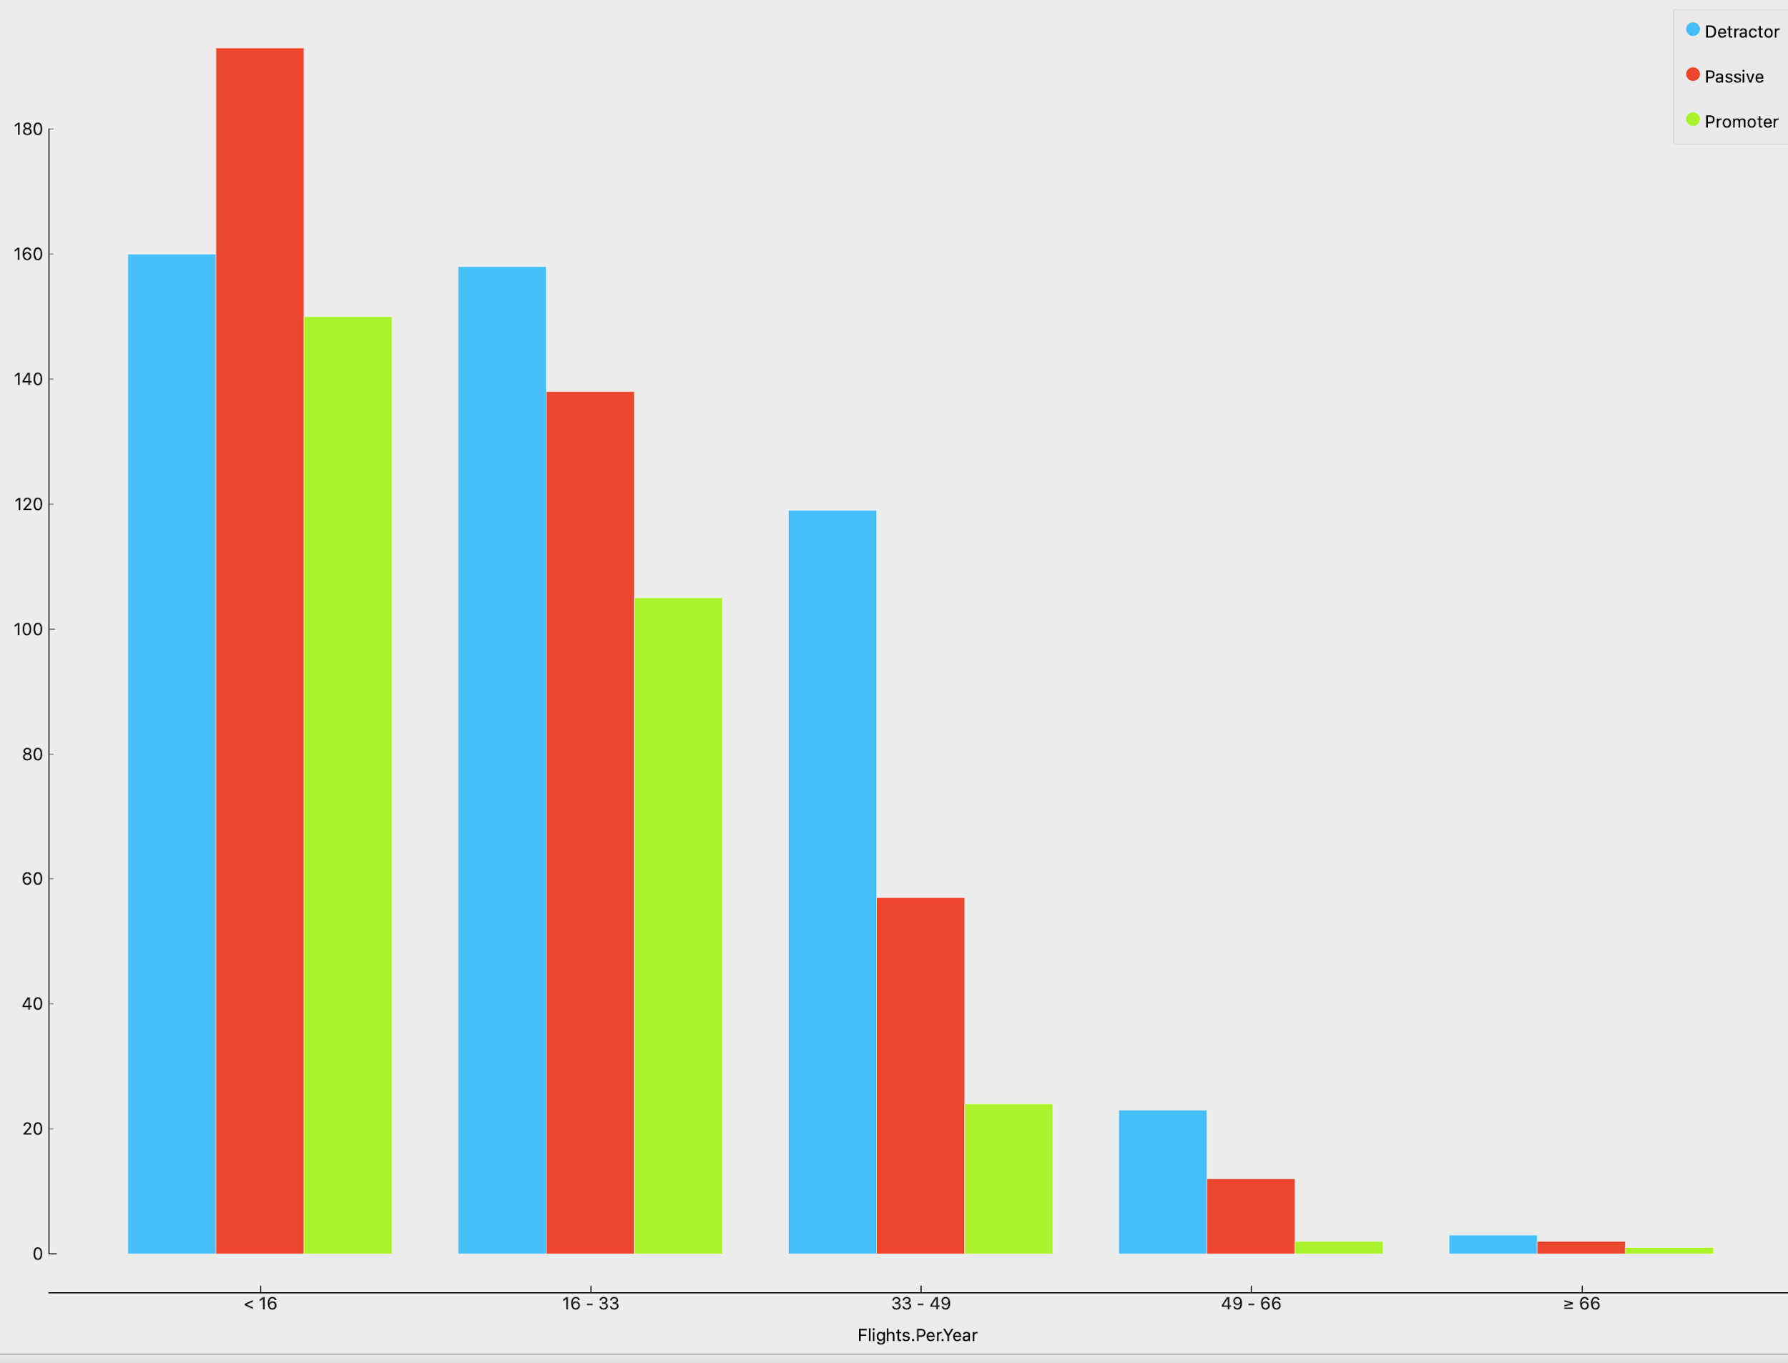

**(3)Price sensitivity**

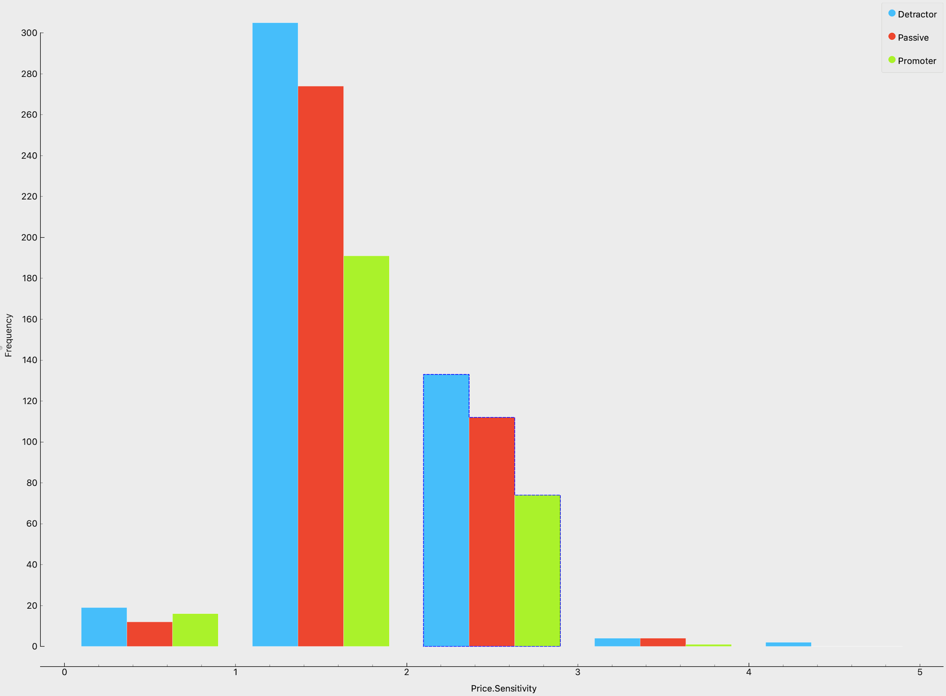

**(4)Age**

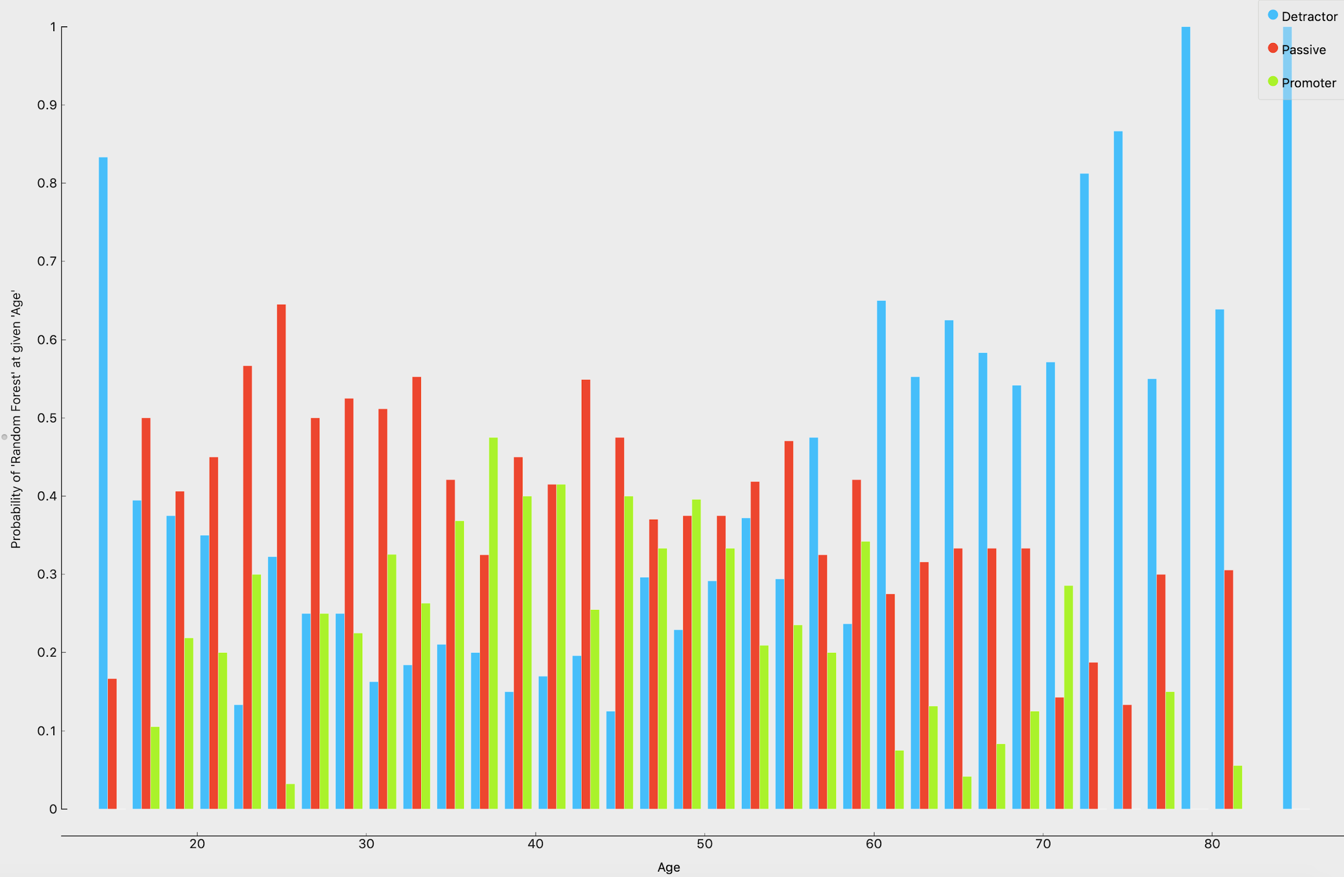

**(5)Gender**

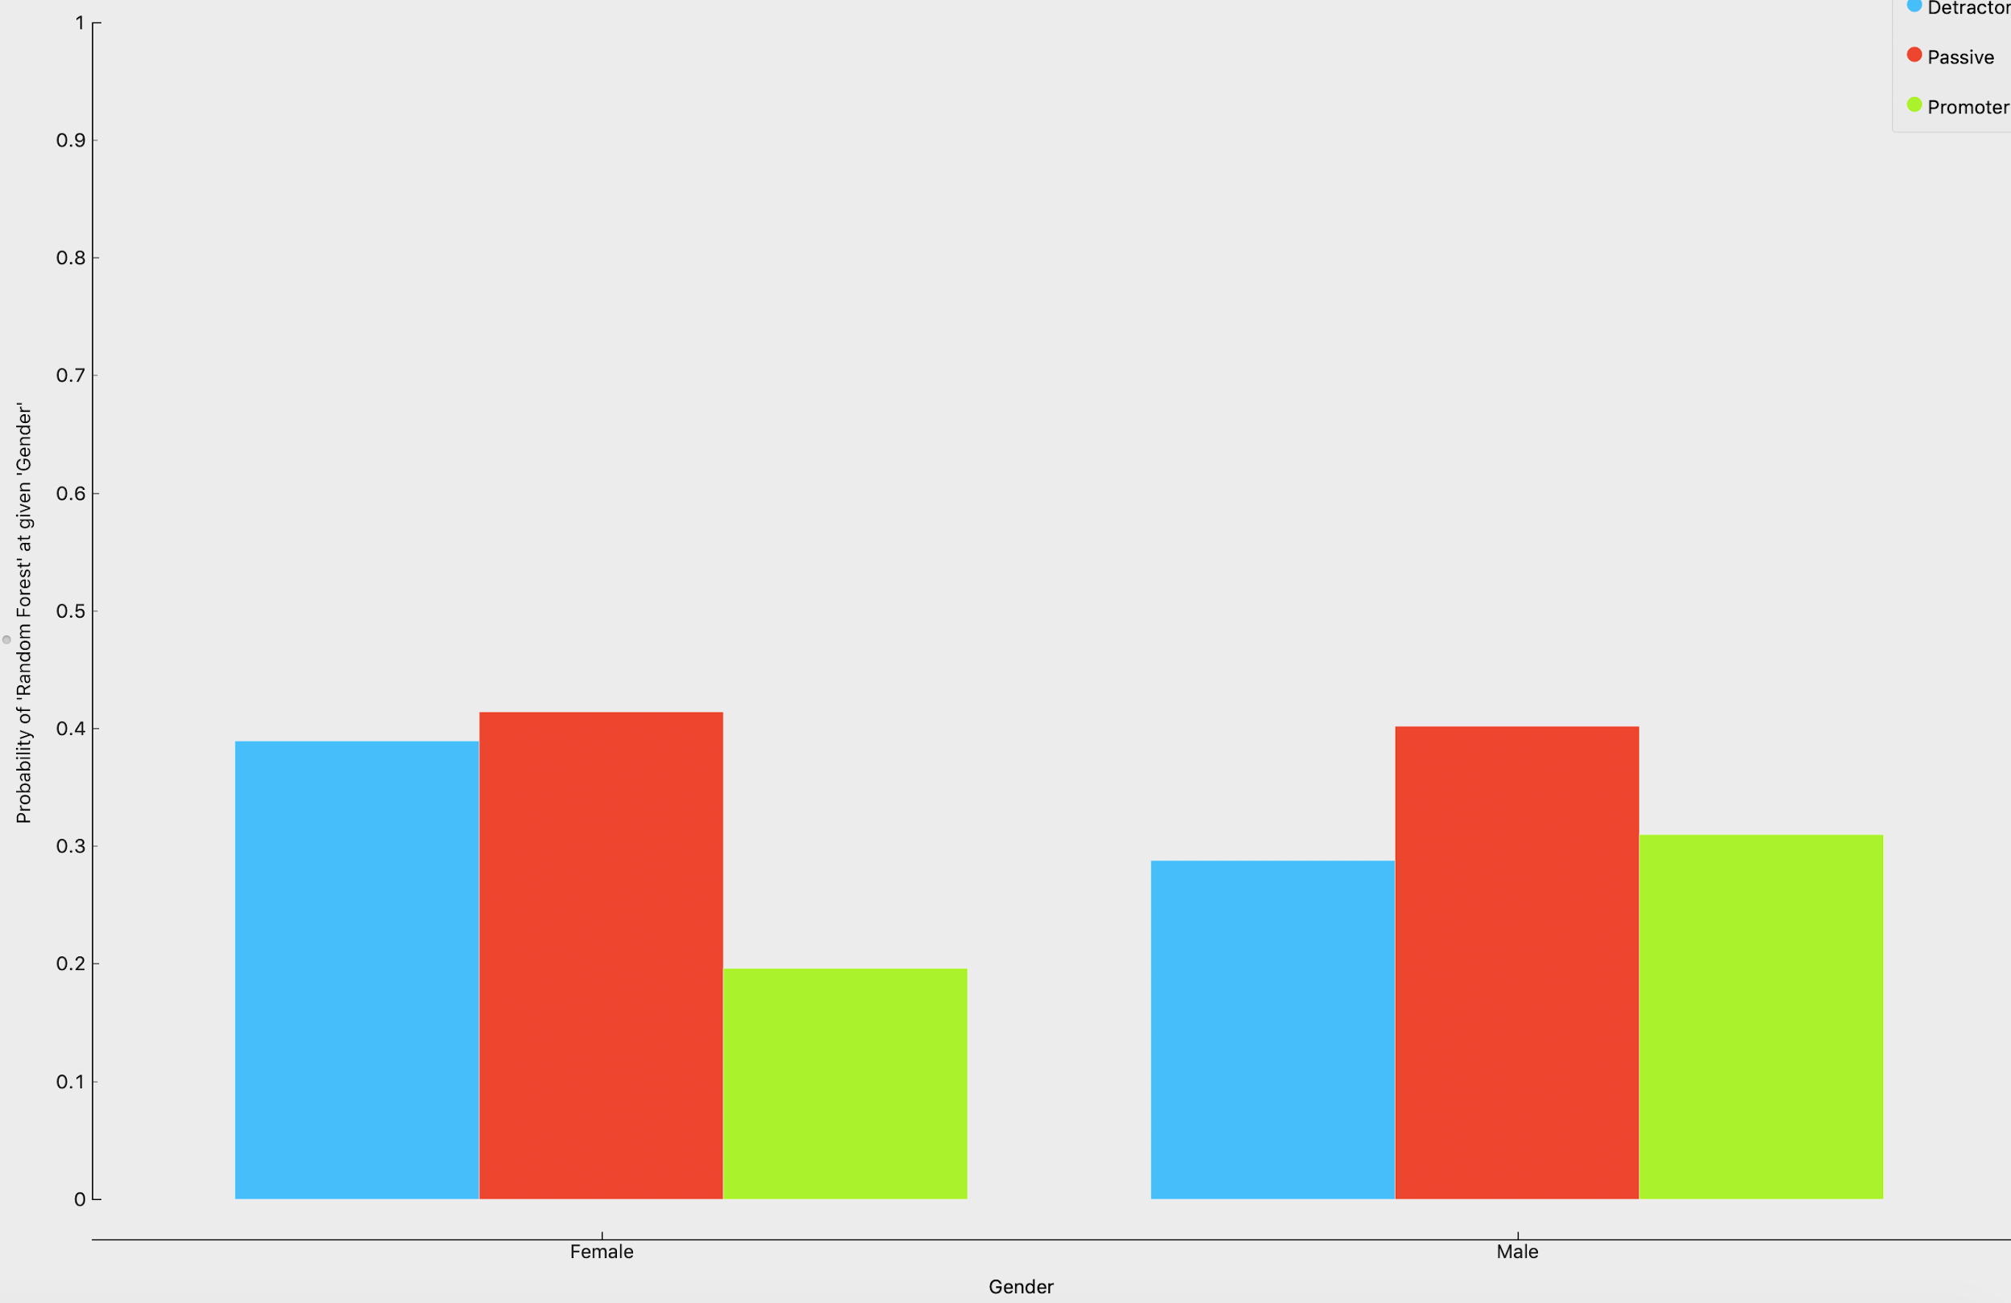

From the distribution we got from random forest prediction, we could see that **personal type of travel, large number of flights per year, customers (age>60), high price sensitivity, female customers** tend to be more possible to be a detractor.

## Other two Airways Inc.

To improve the proportion of passive and promoters, we need to improve the satisfaction of above the mentioned customers. In order to figure out how to do it, we took a look at the promoters of other companies.

As for price sensitivity:

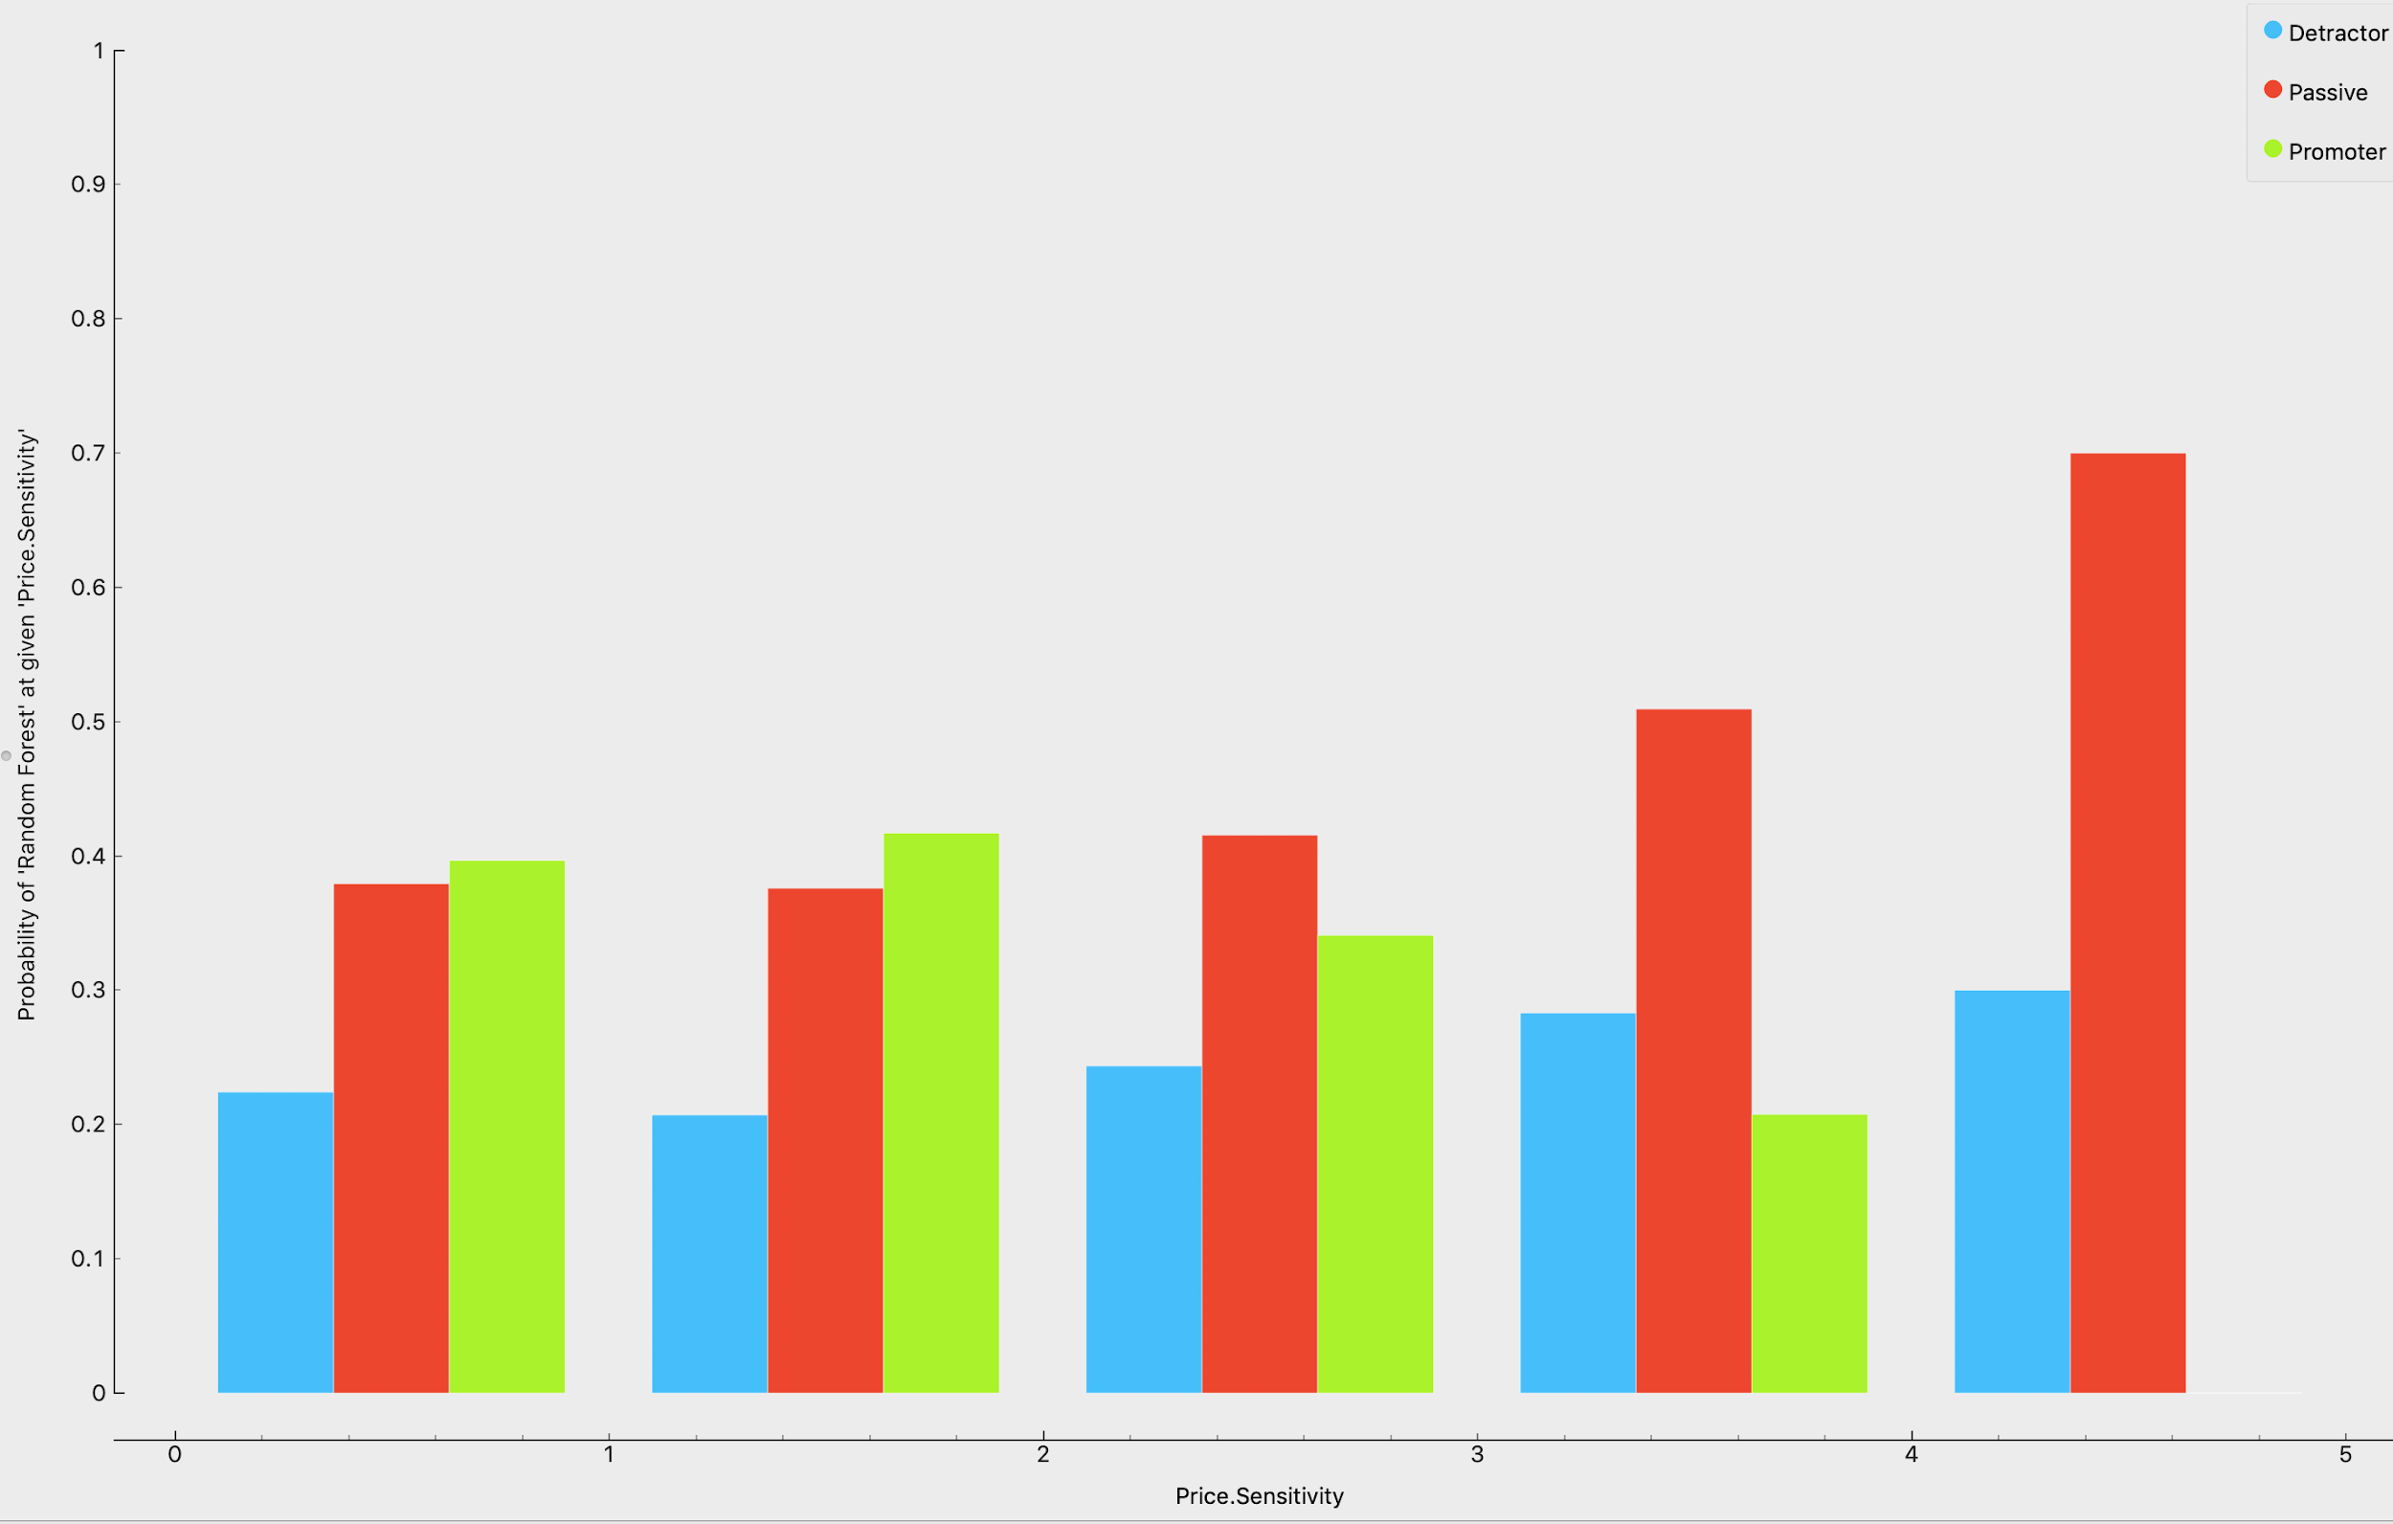

The other two companies have high promoter probability on high price sensitivity, which is different with FlyFast company. Then we focused on the high price sensitivity, we set the filter condition as price sensitivity > 3 and got the following result.

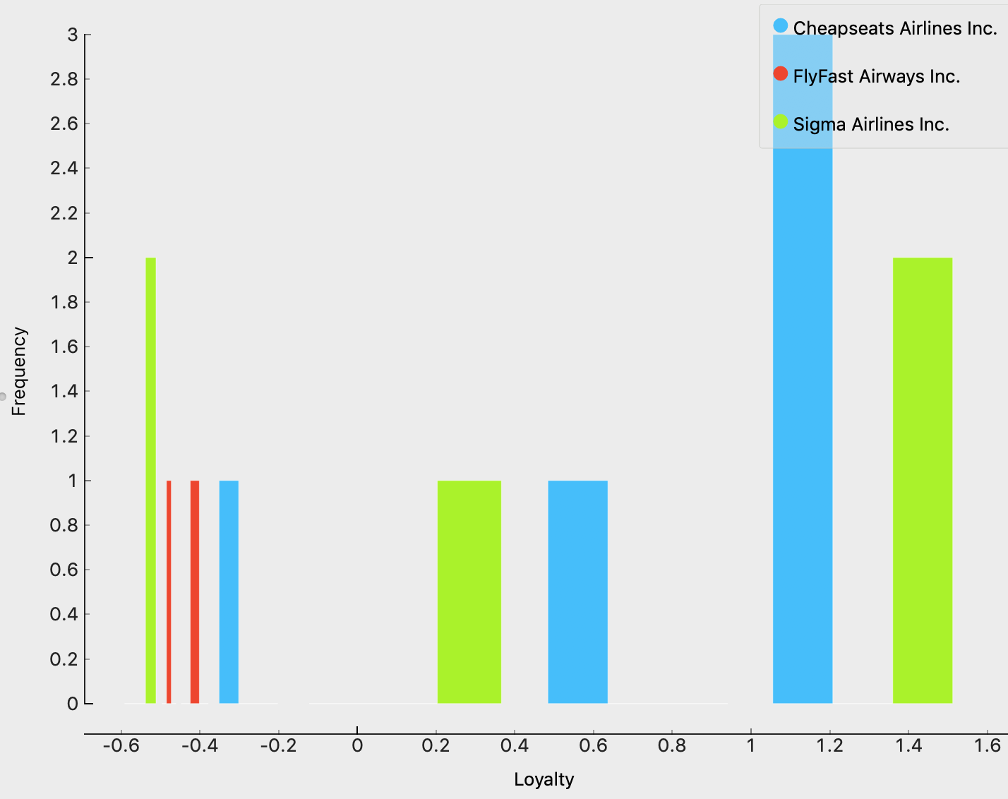

For those customers who have large price sensitivity, FlyFast Airways has way lower loyalty than the other two companies. We all know that loyalty and price sensitivity could be related to each other, but for Cheapseats and Sigma, they could still maintain the customers’ loyalty who are sensitive to the price. That could be one part that FlyFast Airways need to figure out.

As for Age:

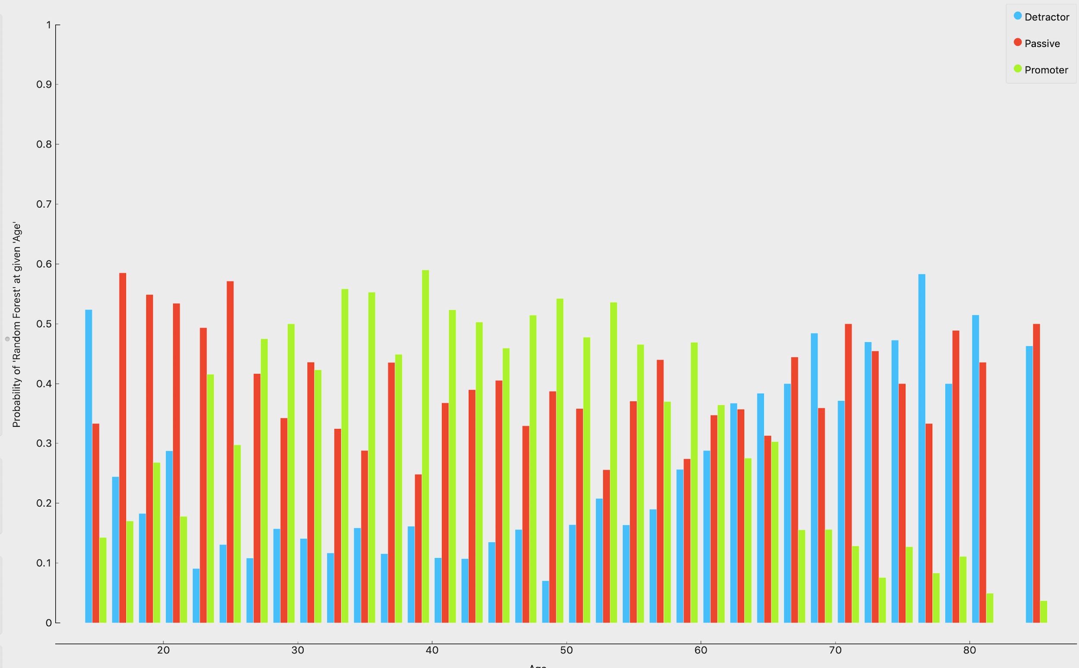

Compared with FlyFast, customers (age >60) of other two companies have better satisfaction.

As for gender:

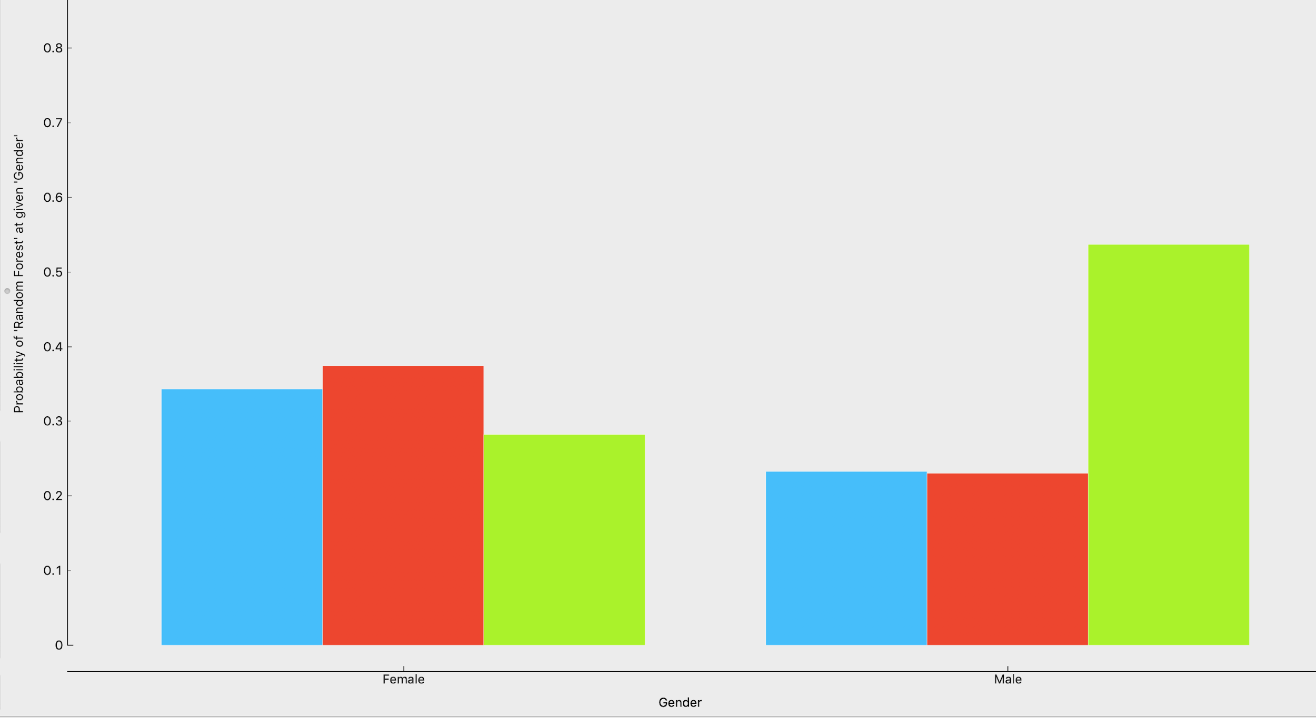

The other two companies have a higher proportion of promoters among male customers.

For the class:

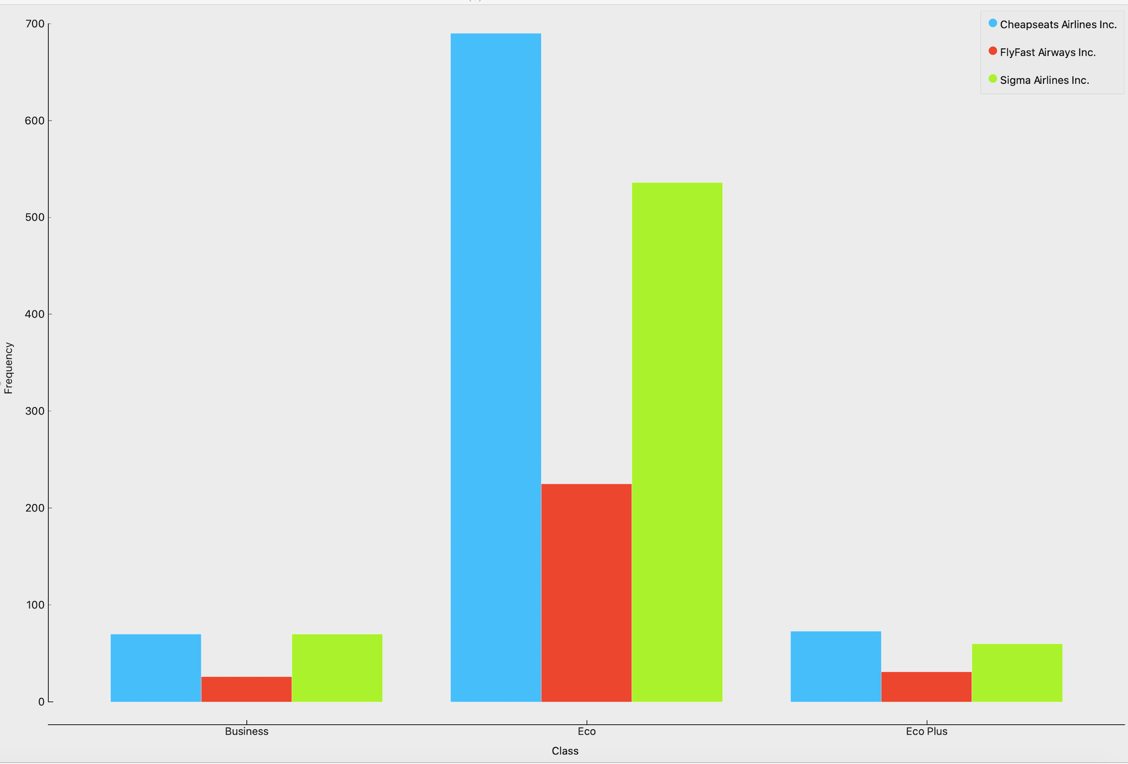

This chart shows the distribution of promoters for different classes. Most recommendations were given by Eco class customers. However, FlyFast Airwaysis far from the other two companies in this section.

For the cancelled flights:

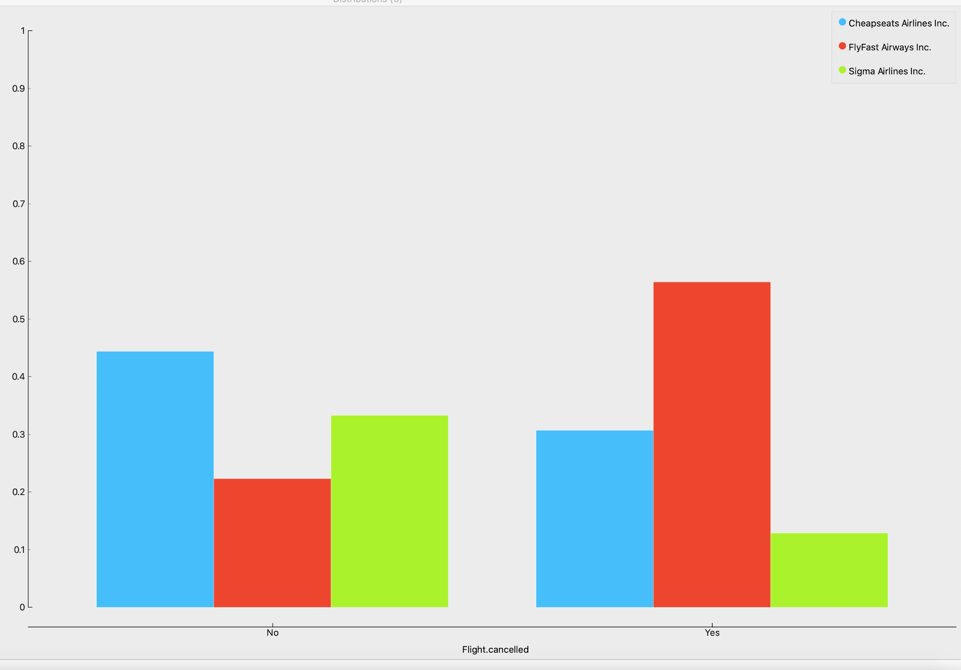

The FlyFast Airlines has more cancelled flights than its competitors, which may affect experience for customers.

## Conclusion

To sum up, the business insights gained in this phase are listed as follows:

* In the FlyFast Airways Inc. part
  + Low proportion of promoters
  + Personal type of travel, large number of flights per year, customers (age>60), high price sensitivity, female customers are more likely to be detractors
* Compared with other Airways
  + High price sensitivity customers of other Airways are more likely to be promoters. And those customers have higher loyalty scores.
  + Male and senior customers are more satisfied than FlyFast Airways Inc.
  + Other Airways customers of Eco class gave higher NPS scores
  + Less cancelled flights

## Marketing Plan

We have done reasonable segmentation, sentiment analysis and predictive models, and we got a lot of intuitive business insights. Some of them are only theoretical and some other insights could bring up actionable marketing plans to increase the NPS for the segment.

## Segment Persona’s

We defined the demographic / behavioral characteristics associated with Persona’s as follows:

*Age, Gender, Price Sensitivity, Flights per year, Loyalty, Type of travel, Class.* And we would give some actionable ideas combining the results of sentiment analysis and predictive models for those market segments.

Typical customer characteristics:

|  |  |
| --- | --- |
| Promoter | |
| Age | 32-44 |
| Type of Travel | Personal Travel |
| Gender | Female |

|  |  |
| --- | --- |
| Detractors | |
| Age | >=58 |
| Type of Travel | Business |
| Delay | >=28 |

|  |  |
| --- | --- |
| Passive | |
| Airline Status | Gold |
| Partner | FlyFast Airways Inc |
| Delay | Female |

## Market Plan for the segmentation

The summarization of actionable market plans for the market segmentation:

* From sentiment analysis:
  + **Do a further survey about the southeast.** For all types of travel, some people said it was awful and other people said it was not bad. Based on the existing information, we could say there must be some parts of it that could be improved.
  + **Improve the compensation standard for flight delays.** Most people care about the delay very much (low, medium, high sentiment value). It could be hard to avoid all the delays since they could be caused by complicated reasons. But we could do something to improve the customers’ satisfaction. Sometimes small gifts do not cost much, but they could exert a mood-enhancing effect on customers.
  + **Better arrangement of seats and clear pricing rules.** Some customers of *FlyFast Airways Inc.* complained about the seats, pricing, and equipment. We may not be able to change the equipment in the short term. But we could improve our service instead, for example, replacing the confusing policies about seats and pricing by easy-understanding and clear ones could improve the satisfaction efficiently and cost little.
  + **Timely notification to the customers.** In our sentiment analysis, we found a lot of people met the situation that they needed to wait but they did not know why. This situation could be very irritating, while this could be solved easily by making earlier notification, people could have time to rearrange their schedule and calm down, especially for those low sentiment value customers.
* From predictive models:
  + **Pay more attention to the personal type of travel and Eco class flight.** The model predictions show that the personal type of travel and eco class customers are more likely to be detractors. And from the distribution visualization we could find most of the personal travel customers chose the Eco ticket, which means they are mostly the same segmentation of customers. Considering the result we got from sentiment analysis, if we could make a mild change on our flight service, they could change their mind (detractor to promoters).
  + **Treat better to the frequent visitors.** Evidence shows that frequent visitors tend to be detractors (have many flights per year). Those customers are the treasure of the airways company, we need to do something other than wait for them to leave and choose other companies. Discount, little surprise gifts or even one more friendly greeting could make a difference.
  + **Specific nice service to senior customers**. From the predictive model predictions, we could see the senior customers (especially age > 60) are not satisfied in most cases. Seniors, being inconvenient in movement, would be uncomfortable waiting at the airport or during the flight. To improve the NPS scores of them, we could set special resting areas in the airport to let them sit comfortably and have a drink. Or we could warmly provide a comfortable blanket for seniors during the flight.
  + **Improve the service of cheap flights.** Those customers with high price sensitivity tend to have a low loyalty score and are less likely to make a recommendation. Since it could be costly to change equipment in the cheap flights, but we could improve our service like those mentioned in the sentiment analysis to improve the loyalty scores and retain customers.

# reference

1. IST 707, Project description R1 documentation

2. IST 707, Project Information powerpoint file

3. Orange Data Mining Documentation, <https://orange.biolab.si/docs/>

4. Orange Data Mining Youtube Tutorial,<https://www.youtube.com/channel/UClKKWBe2SCAEyv7ZNGhIe4g>

5. Improve NPS score videos, <https://www.youtube.com/watch?v=UAZpnjRiRN0>

6. Many times of review of class recording video